PROJECT- Time Series forecasting

ADITHYA MANIVANNAN

PGP - DSBA

Contents

INTRODUCTION 2

PROBLEM - Wine Sales 2

SYNOPSIS 2

1) Read the data as an appropriate Time Series data and plot the data. 3

2) Perform appropriate Exploratory Data Analysis to understand the data and also perform decomposition. 5

• yt = Trend * Seasonalit y * Residual 10

3) Split the data into training and test. The test data should start in 1991. 10

4) Build various exponential smoothing models on the training data and evaluate the model using RMSE on the test data. Other models such as regression, naïve forecast models, simple average models etc. should also be built on the training data and check the performance on the test data using RMSE. 13

5) Check for the stationarity of the data on which the model is being built on using appropriate statistical tests and also mention the hypothesis for the statistical test. 35

6) Build an automated version of the ARIMA/SARIMA model in which the parameters are selected using the lowest Akaike Information Criteria (AIC) on the training data and evaluate this model on the test data using RMSE 37

7) Build ARIMA/SARIMA models based on the cut-off points of ACF and PACF on the training data and evaluate this model on the test data using RMSE. 43

8) Build a table (create a data frame) with all the models built along with their corresponding parameters and the respective RMSE values on the test data. 54

9) Based on the model-building exercise, build the most optimum model(s) on the complete data and predict 12 months into the future with appropriate confidence intervals/bands. 56

10) Comment on the model thus built and report your findings and suggest the measures that the company should be taking for future sales. 59

Rose Wine Sales - Comments : 59

Rose Wine Sales - Forecast Models : 60

Rose Wine Sales - Suggestions : 60

Sparkling Wine Sales - Comments : 61

Sparkling Wine Sales - Forecast Models : 62

Sparkling Wine Sales - Suggestions : 62

# INTRODUCTION

This report consists of Time Series analysis and forecasting of 2 datasets -

* DATASET 1 - Sales data of Rose Wine
* DATASET 2 - Sales data of Sparkling Wine

Please find the Jupyter Code Notebook here. Analysis code is in Python.

# PROBLEM - Wine Sales

For this particular assignment, the data of different types of wine sales in the 20th century is to be analysed.

Both of these data are from the same company but of different wines. As an analyst in the ABC Estate Wines, you are tasked to analyse and forecast Wine Sales in the 20th century.

Datasets used - Sales of Rose Wine and Sparkling Wine

# SYNOPSIS

1. Total No. Of Rose Data Entries = 187 Total No. Of Sparkling Data Entries = 187
2. No. Of Missing Values in Rose data = 2

- We use INTERPOLATION to impute these missing values No. Of Missing Values in Sparkling data = 0

1. No. Of Duplicate entries in Rose data = 0

No. Of Duplicate entries in Sparkling data = 0

1. Both datasets are split in Train: Test at year 1991 - Test data starts at 1991
2. Various forecasting models applied are -
   1. Linear Regression
   2. Naive Bayes
   3. Simple Average
   4. 2-pt Moving Average
   5. 4-pt Moving Average
   6. 6-pt Moving Average
   7. 9-pt Moving Average
   8. Single Exponential Smoothing
   9. Double Exponential Smoothing (Holt’s Model)
   10. Triple Exponential Smoothing (Holt-Winter Model)
   11. ARIMA / SARIMA (Auto fitted)
   12. ARIMA / SARIMA (Manually fitted)

## 1) Read the data as an appropriate Time Series data and plot the data.

* Both Datasets are read and stored as Pandas Data Frames for analysis
* Datasets are read as Time Series data using parse_dates=True & index_col=‘YearMonth’
* First 5 rows of both the data are given below -

|  |  |
| --- | --- |
| **YearMonth** | Rose |
| **1980-01-01** | 112.0 |
| **1980-02-01** | 118.0 |
| **1980-03-01** | 129.0 |
| **1980-04-01** | 99.0 |
| **1980-05-01** | 116.0 |

|  |  |
| --- | --- |
| **YearMonth** | Sparkling |
| **1980-01-01** | 1686 |
| **1980-02-01** | 1591 |
| **1980-03-01** | 2304 |
| **1980-04-01** | 1712 |
| **1980-05-01** | 1471 |

Rose Data Header Sparkling Data Header

* Rose Data plot -

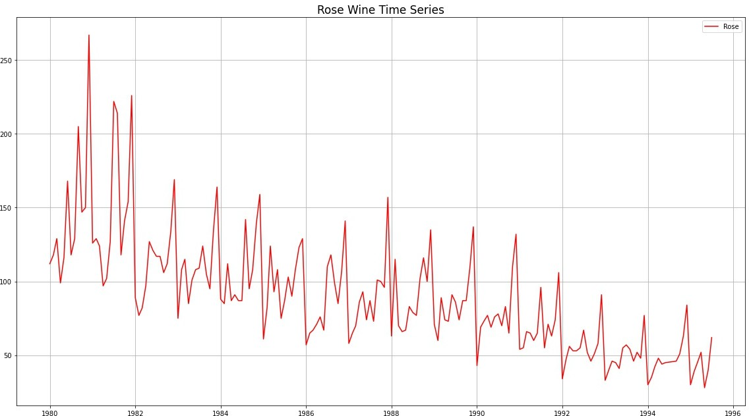

* Sparkling Data plot -

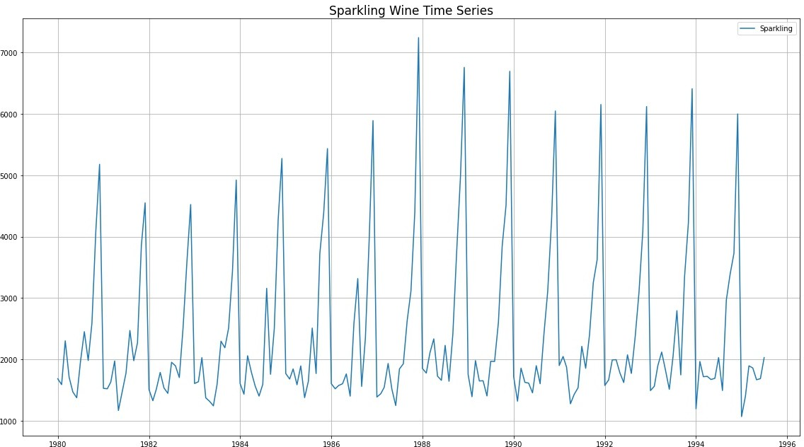

## 2) Perform appropriate Exploratory Data Analysis to understand the data and also perform decomposition.

#### Exploratory Data Analysis -

|  |  |  |  |  |  |  |  |  |
| --- | --- | --- | --- | --- | --- | --- | --- | --- |
|  | count | mean | std | min | 25% | 50% | 75% | max |
| **Rose** | 187.0 | 89.914 | 39.238 | 28.0 | 62.5 | 85.0 | 111.0 | 267.0 |
| **Sparkling** | 187.0 | 2402.417 | 1295.112 | 1070.0 | 1605.0 | 1874.0 | 2549.0 | 7242.0 |

Descriptive Stats of Rose and Sparkling datasets

<class 'pandas.core.frame.DataFrame'> DatetimeIndex: 187 entries,

1980-01-01 to 1995-07-01

Data columns (total 1 columns):

# Column Non-Null Count Dtype

0 Rose

187 non-null

float64

dtypes: float64(1) memory usage: 2.9 KB

<class 'pandas.core.frame.DataFrame'> DatetimeIndex: 187 entries,

1980-01-01 to 1995-07-01

Data columns (total 1 columns):

# Column Non-Null Count Dtype

0 Sparkling 187 non-null

int64

dtypes: int64(1) memory usage: 2.9 KB

Info - Rose data Info - Sparkling data

* Month-wise Boxplot of Rose -

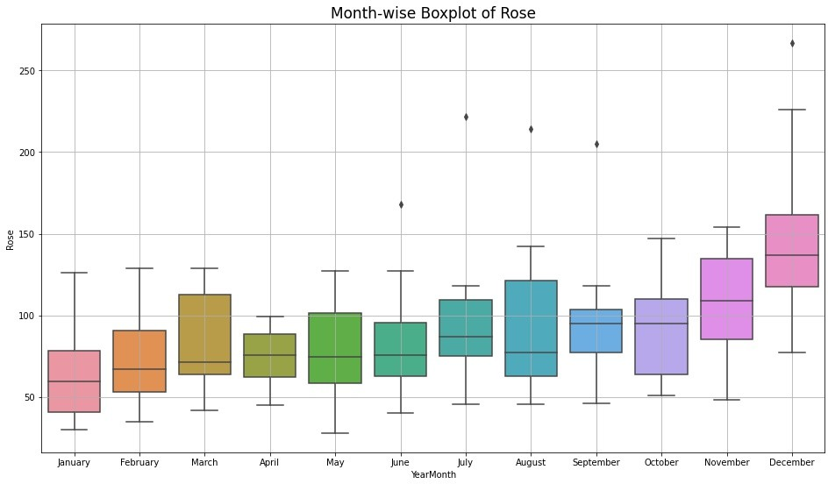

* Month-wise Boxplot of Sparkling -

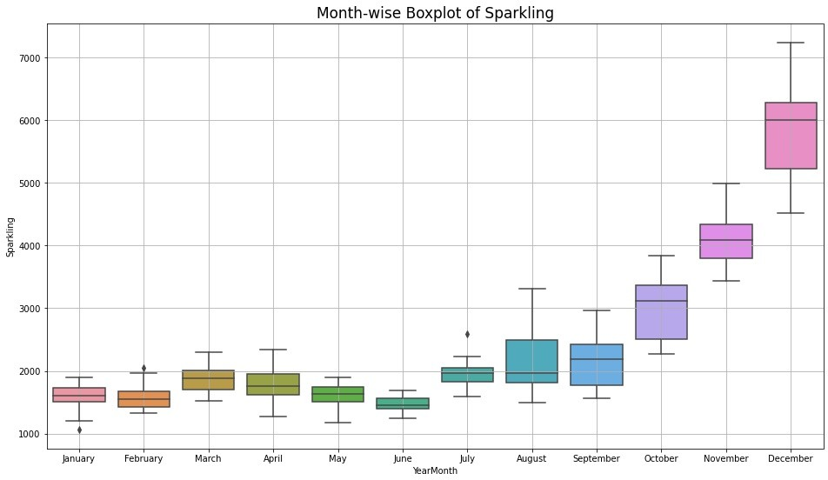

* + Sales of both - Rose and Sparkling, show a spike in the last quarter of Oct to Dec
  + Spike is much more accentuated in Sparkling sales
  + This spike may be due to the Holiday season starting in Oct

#### Additive Decomposition of Rose -

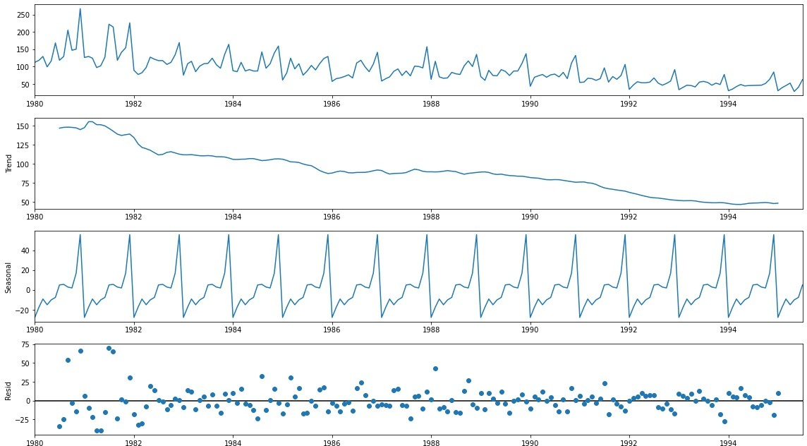

|  |  |
| --- | --- |
| **YearMonth** | trend |
| **1980-01-01** |  |
| **1980-02-01** |  |
| **1980-03-01** |  |
| **1980-04-01** |  |
| **1980-05-01** |  |
| **1980-06-01** |  |
| **1980-07-01** | 147.08 |
| **1980-08-01** | 148.13 |
| **1980-09-01** | 148.38 |
| **1980-10-01** | 148.08 |
| **1980-11-01** | 147.42 |
| **1980-12-01** | 145.13 |

|  |  |
| --- | --- |
| **YearMonth** | seasonal |
| **1980-01-01** | -27.91 |
| **1980-02-01** | -17.44 |
| **1980-03-01** | -9.29 |
| **1980-04-01** | -15.10 |
| **1980-05-01** | -10.20 |
| **1980-06-01** | -7.68 |
| **1980-07-01** | 4.90 |
| **1980-08-01** | 5.50 |
| **1980-09-01** | 2.77 |
| **1980-10-01** | 1.87 |
| **1980-11-01** | 16.85 |
| **1980-12-01** | 55.71 |

|  |  |
| --- | --- |
| **YearMonth** | resid |
| **1980-01-01** |  |
| **1980-02-01** |  |
| **1980-03-01** |  |
| **1980-04-01** |  |
| **1980-05-01** |  |
| **1980-06-01** |  |
| **1980-07-01** | -33.98 |
| **1980-08-01** | -24.62 |
| **1980-09-01** | 53.85 |
| **1980-10-01** | -2.96 |
| **1980-11-01** | -14.26 |
| **1980-12-01** | 66.16 |

Rose Trend

Rose Seasonality

Rose Residual

#### Multiplicative Decomposition of Rose -

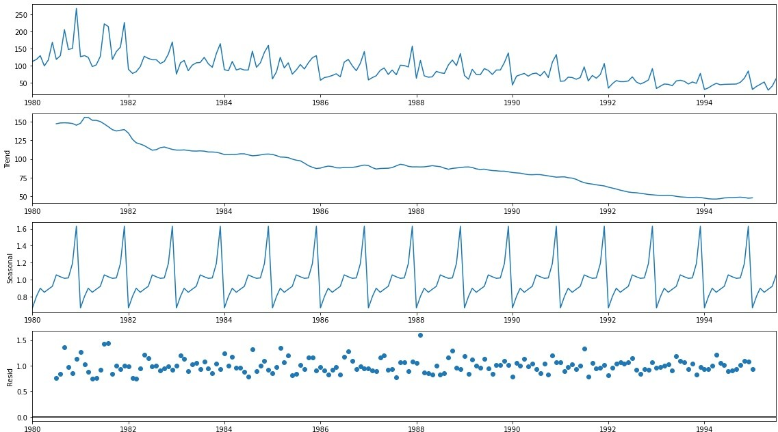

|  |  |
| --- | --- |
| **YearMonth** | trend |
| **1980-01-01** |  |
| **1980-02-01** |  |
| **1980-03-01** |  |
| **1980-04-01** |  |
| **1980-05-01** |  |
| **1980-06-01** |  |
| **1980-07-01** | 147.08 |
| **1980-08-01** | 148.13 |
| **1980-09-01** | 148.38 |
| **1980-10-01** | 148.08 |
| **1980-11-01** | 147.42 |
| **1980-12-01** | 145.13 |

|  |  |
| --- | --- |
| **YearMonth** | seasonal |
| **1980-01-01** | 0.67 |
| **1980-02-01** | 0.81 |
| **1980-03-01** | 0.90 |
| **1980-04-01** | 0.85 |
| **1980-05-01** | 0.89 |
| **1980-06-01** | 0.92 |
| **1980-07-01** | 1.06 |
| **1980-08-01** | 1.04 |
| **1980-09-01** | 1.02 |
| **1980-10-01** | 1.02 |
| **1980-11-01** | 1.19 |
| **1980-12-01** | 1.63 |

|  |  |
| --- | --- |
| **YearMonth** | resid |
| **1980-01-01** |  |
| **1980-02-01** |  |
| **1980-03-01** |  |
| **1980-04-01** |  |
| **1980-05-01** |  |
| **1980-06-01** |  |
| **1980-07-01** | 0.76 |
| **1980-08-01** | 0.84 |
| **1980-09-01** | 1.36 |
| **1980-10-01** | 0.97 |
| **1980-11-01** | 0.85 |
| **1980-12-01** | 1.13 |

Rose Trend

Rose Seasonality

Rose Residual

#### Additive Decomposition of Sparkling -

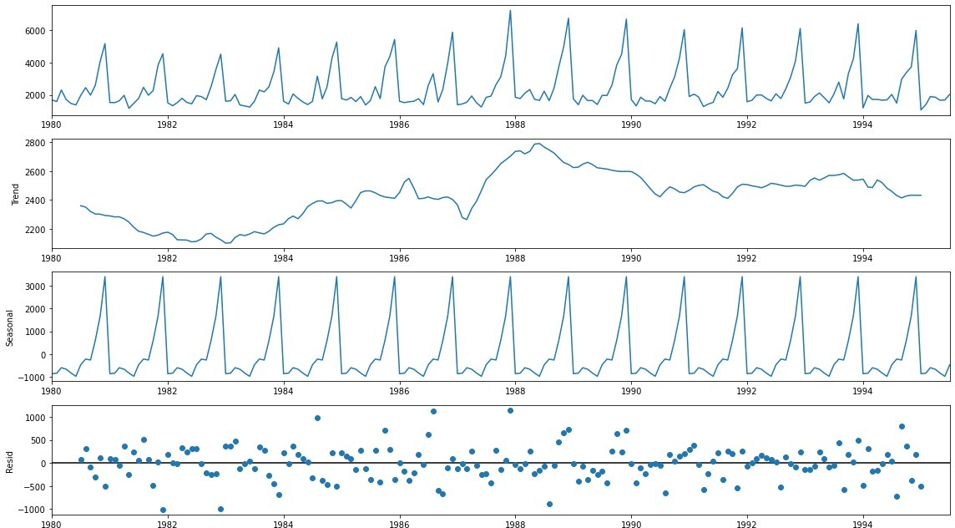

|  |  |
| --- | --- |
| **YearMonth** | trend |
| **1980-01-01** |  |
| **1980-02-01** |  |
| **1980-03-01** |  |
| **1980-04-01** |  |
| **1980-05-01** |  |
| **1980-06-01** |  |
| **1980-07-01** | 2360.67 |
| **1980-08-01** | 2351.33 |
| **1980-09-01** | 2320.54 |
| **1980-10-01** | 2303.58 |
| **1980-11-01** | 2302.04 |
| **1980-12-01** | 2293.79 |

|  |  |
| --- | --- |
| **YearMonth** | seasonal |
| **1980-01-01** | -854.26 |
| **1980-02-01** | -830.35 |
| **1980-03-01** | -592.36 |
| **1980-04-01** | -658.49 |
| **1980-05-01** | -824.42 |
| **1980-06-01** | -967.43 |
| **1980-07-01** | -465.50 |
| **1980-08-01** | -214.33 |
| **1980-09-01** | -254.68 |
| **1980-10-01** | 599.77 |
| **1980-11-01** | 1675.07 |
| **1980-12-01** | 3386.98 |

|  |  |
| --- | --- |
| **YearMonth** | resid |
| **1980-01-01** |  |
| **1980-02-01** |  |
| **1980-03-01** |  |
| **1980-04-01** |  |
| **1980-05-01** |  |
| **1980-06-01** |  |
| **1980-07-01** | 70.84 |
| **1980-08-01** | 316.00 |
| **1980-09-01** | -81.86 |
| **1980-10-01** | -307.35 |
| **1980-11-01** | 109.89 |
| **1980-12-01** | -501.78 |

Sparkling Trend

Sparkling Seasonality

Sparkling Residual

#### Multiplicative Decomposition of Sparkling -

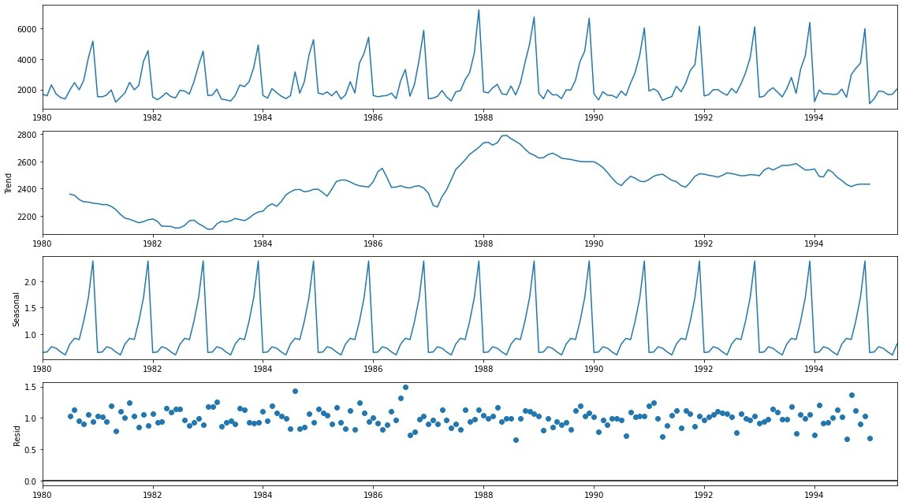

|  |  |
| --- | --- |
| **YearMonth** | trend |
| **1980-01-01** |  |
| **1980-02-01** |  |
| **1980-03-01** |  |
| **1980-04-01** |  |
| **1980-05-01** |  |
| **1980-06-01** |  |
| **1980-07-01** | 2360.67 |
| **1980-08-01** | 2351.33 |
| **1980-09-01** | 2320.54 |
| **1980-10-01** | 2303.58 |
| **1980-11-01** | 2302.04 |
| **1980-12-01** | 2293.79 |

|  |  |
| --- | --- |
| **YearMonth** | seasonal |
| **1980-01-01** | 0.65 |
| **1980-02-01** | 0.66 |
| **1980-03-01** | 0.76 |
| **1980-04-01** | 0.73 |
| **1980-05-01** | 0.66 |
| **1980-06-01** | 0.60 |
| **1980-07-01** | 0.81 |
| **1980-08-01** | 0.92 |
| **1980-09-01** | 0.89 |
| **1980-10-01** | 1.24 |
| **1980-11-01** | 1.69 |
| **1980-12-01** | 2.38 |

|  |  |
| --- | --- |
| **YearMonth** | resid |
| **1980-01-01** |  |
| **1980-02-01** |  |
| **1980-03-01** |  |
| **1980-04-01** |  |
| **1980-05-01** |  |
| **1980-06-01** |  |
| **1980-07-01** | 1.03 |
| **1980-08-01** | 1.14 |
| **1980-09-01** | 0.96 |
| **1980-10-01** | 0.91 |
| **1980-11-01** | 1.05 |
| **1980-12-01** | 0.95 |

Sparkling Trend

Sparkling Seasonality

Sparkling Residual

* Additive Models -
  + The seasonality is relatively constant over time
  + *yt* = *Trend* + *Seasonalit y* + *Residual*
* Multiplicative Models -
  + The seasonality increases or decreases over time. It is proportionate to the trend

## yt = Trend * Seasonalit y * Residual

* Here by just observing the Residual patterns of Additive and Multiplicative models of Rose and Sparkling datasets. It seems that -
  + Rose is Multiplicative
  + Sparkling is Additive

## 3) Split the data into training and test. The test data should start in 1991.

* Both datasets of Rose and Sparkling are split at the year 1991
* Test datasets start at 1991

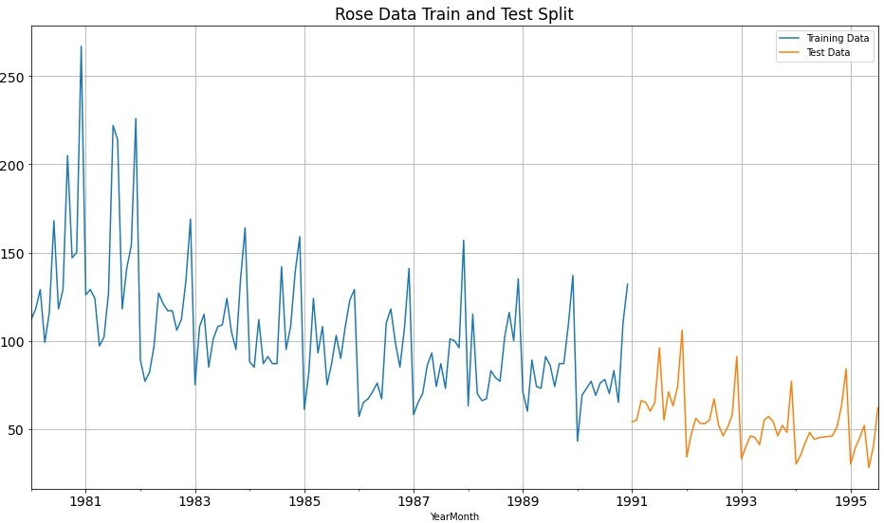

* Rose dataset - TRAIN

|  |  |
| --- | --- |
| **YearMonth** | Rose |
| **1980-01-01** | 112.00 |
| **1980-02-01** | 118.00 |
| **1980-03-01** | 129.00 |
| **1980-04-01** | 99.00 |
| **1980-05-01** | 116.00 |

|  |  |
| --- | --- |
| **YearMonth** | Rose |
| **1990-08-01** | 70.00 |
| **1990-09-01** | 83.00 |
| **1990-10-01** | 65.00 |
| **1990-11-01** | 110.00 |
| **1990-12-01** | 132.00 |

Rose Train - First 5 rows Rose Train - Last 5 rows

* Rose dataset - TEST

|  |  |
| --- | --- |
| **YearMonth** | Rose |
| **1991-01-01** | 54.00 |
| **1991-02-01** | 55.00 |
| **1991-03-01** | 66.00 |
| **1991-04-01** | 65.00 |
| **1991-05-01** | 60.00 |

|  |  |
| --- | --- |
| **YearMonth** | Rose |
| **1995-03-01** | 45.00 |
| **1995-04-01** | 52.00 |
| **1995-05-01** | 28.00 |
| **1995-06-01** | 40.00 |
| **1995-07-01** | 62.00 |

Rose Test - First 5 rows Rose Test - Last 5 rows

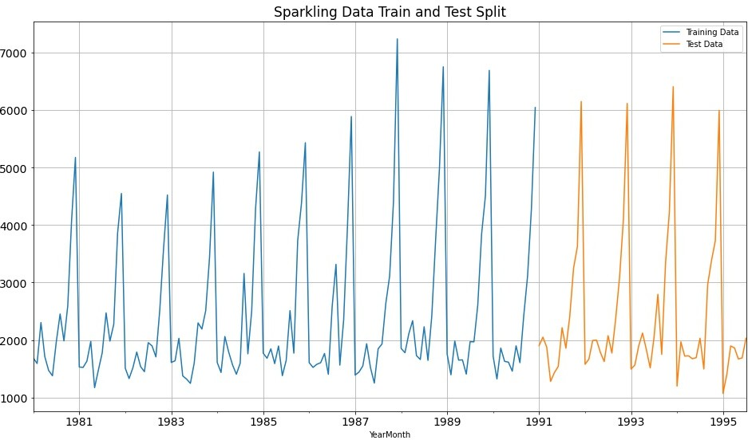

* Sparkling dataset - TRAIN

|  |  |
| --- | --- |
| **YearMonth** | Sparkling |
| **1980-01-01** | 1686.00 |
| **1980-02-01** | 1591.00 |
| **1980-03-01** | 2304.00 |
| **1980-04-01** | 1712.00 |
| **1980-05-01** | 1471.00 |

|  |  |
| --- | --- |
| **YearMonth** | Sparkling |
| **1990-08-01** | 1605.00 |
| **1990-09-01** | 2424.00 |
| **1990-10-01** | 3116.00 |
| **1990-11-01** | 4286.00 |
| **1990-12-01** | 6047.00 |

Sparkling Train - First 5 Sparkling Train - Last 5

* Sparkling dataset - TEST

|  |  |
| --- | --- |
| **YearMonth** | Sparkling |
| **1991-01-01** | 1902.00 |
| **1991-02-01** | 2049.00 |
| **1991-03-01** | 1874.00 |
| **1991-04-01** | 1279.00 |
| **1991-05-01** | 1432.00 |

|  |  |
| --- | --- |
| **YearMonth** | Sparkling |
| **1995-03-01** | 1897.00 |
| **1995-04-01** | 1862.00 |
| **1995-05-01** | 1670.00 |
| **1995-06-01** | 1688.00 |
| **1995-07-01** | 2031.00 |

Sparkling Test - First 5 Sparkling Test - Last 5

## 4) Build various exponential smoothing models on the training data and evaluate the model using RMSE on the test data. Other models such as regression, naïve forecast models, simple average models etc. should also be built on the training data and check the performance on the test data using RMSE.

#### Model 1 - Linear Regression

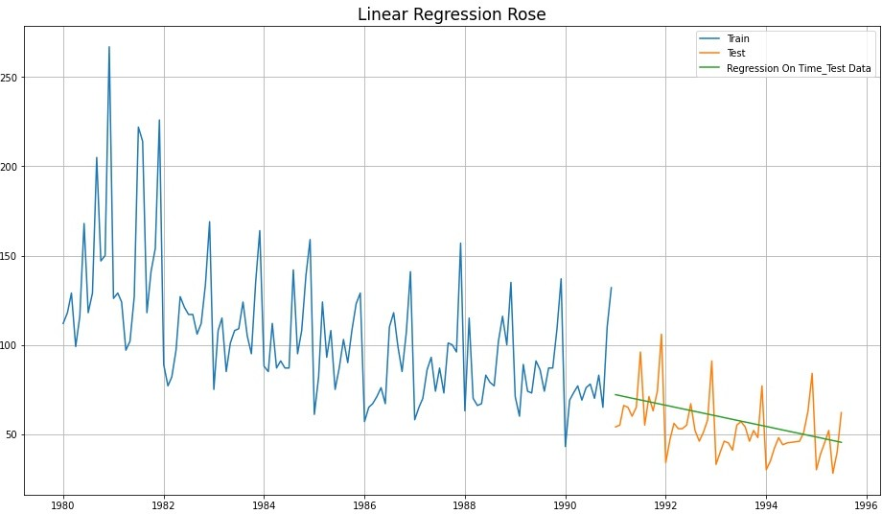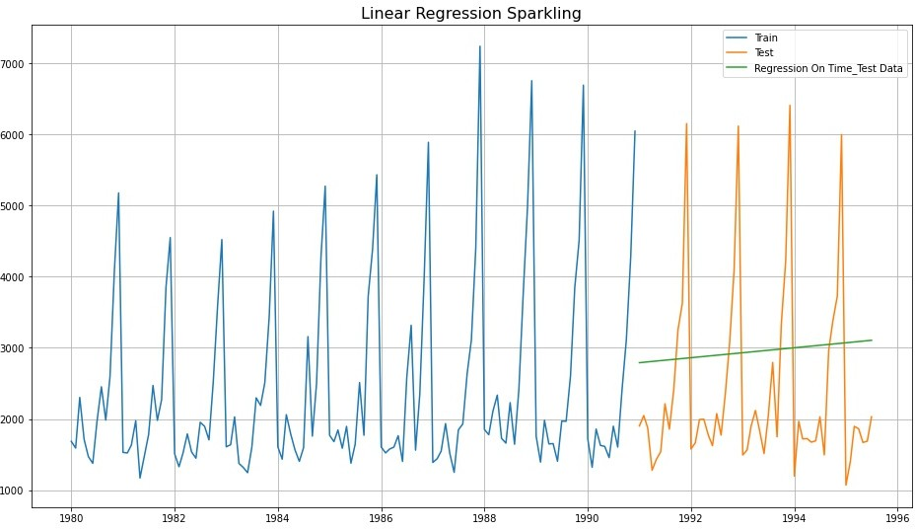

|  |  |  |
| --- | --- | --- |
|  | Test RMSE Rose | **Test RMSE Sparkling** |
| **RegressionOnTime** | 15.27 | 1389.14 |

Model 2 - Naive Bayes

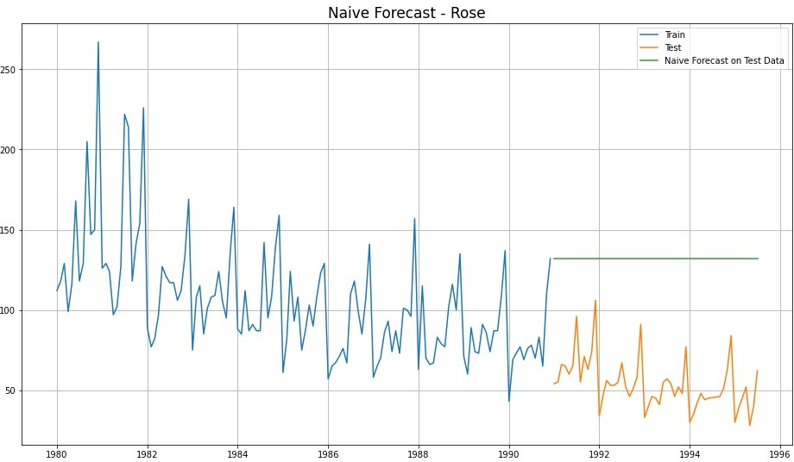

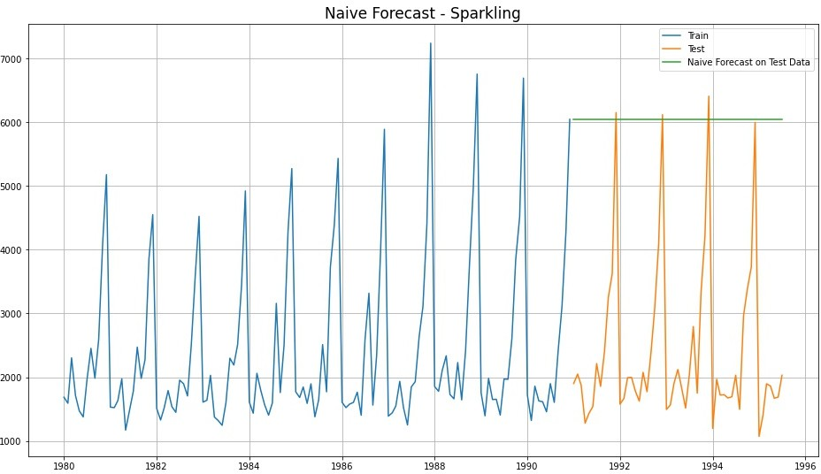

|  |  |  |
| --- | --- | --- |
|  | Test RMSE Rose | **Test RMSE Sparkling** |
| **RegressionOnTime** | 15.27 | 1389.14 |
| **NaiveModel** | 79.72 | 3864.28 |

#### Model 3 - Simple Average

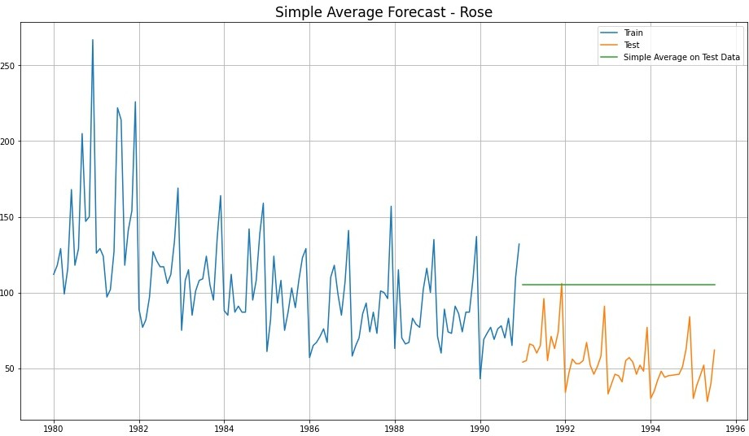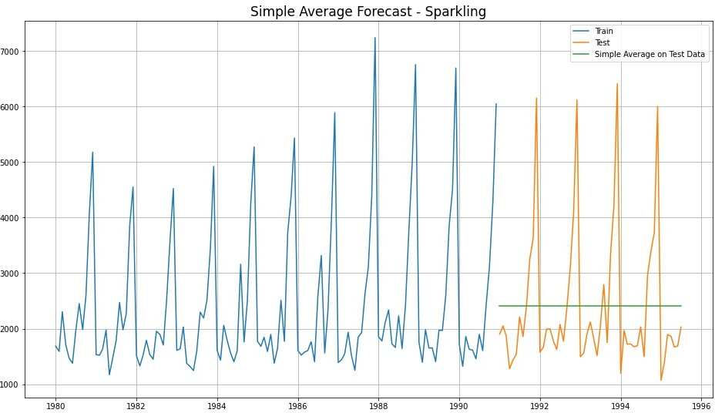

|  |  |  |
| --- | --- | --- |
|  | Test RMSE Rose | **Test RMSE Sparkling** |
| **RegressionOnTime** | 15.27 | 1389.14 |
| **NaiveModel** | 79.72 | 3864.28 |
| **SimpleAverageModel** | 53.46 | 1275.08 |

Model 4.A - Moving Average (Rose)

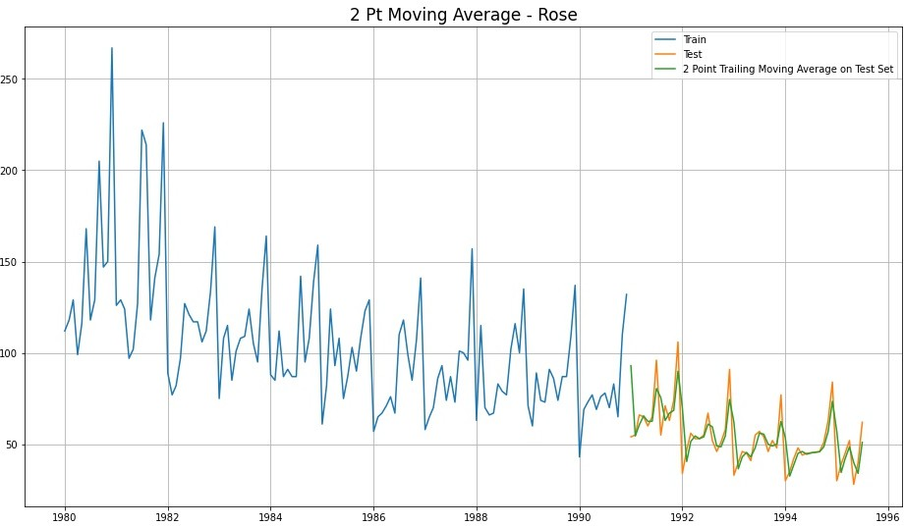

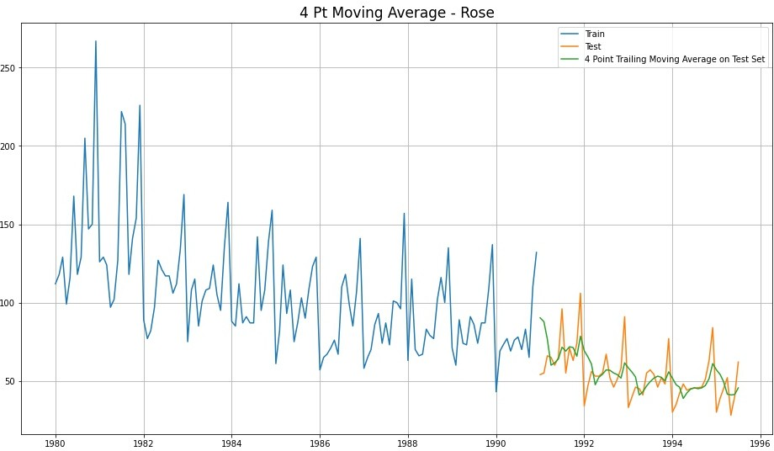

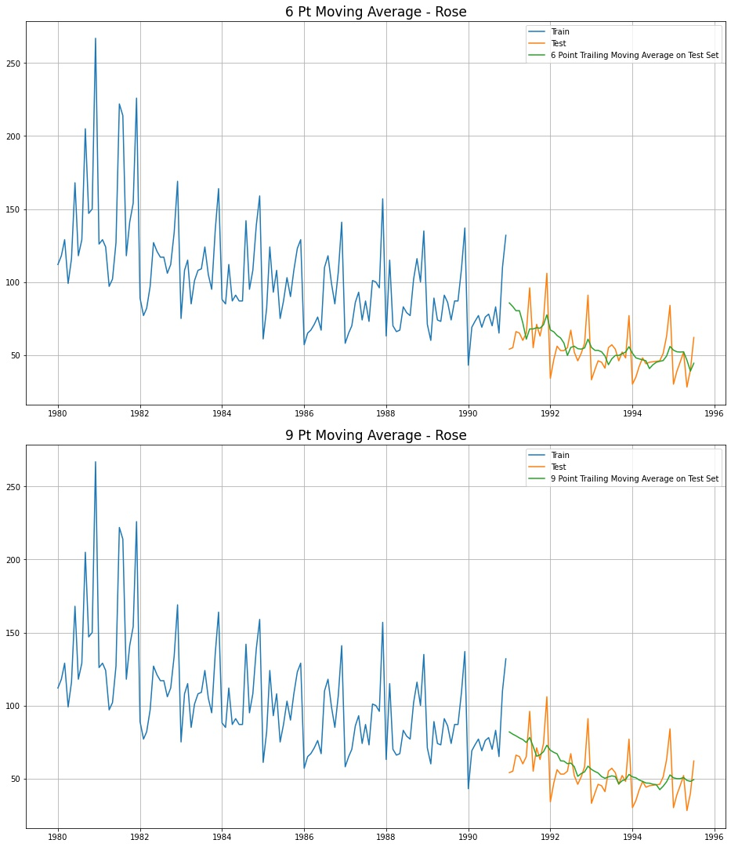

|  |  |
| --- | --- |
|  | Test RMSE Rose |
| **2pointTrailingMovingAverage** | 11.53 |
| **4pointTrailingMovingAverage** | 14.45 |
| **6pointTrailingMovingAverage** | 14.57 |
| **9pointTrailingMovingAverage** | 14.73 |

#### Model 4.B - Moving Average (Sparkling)

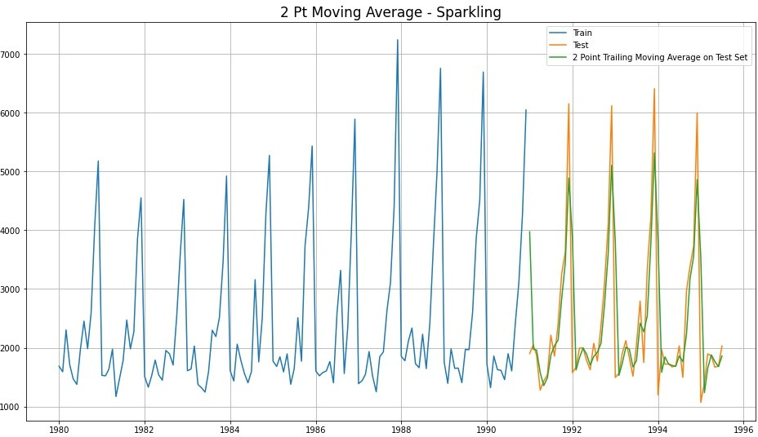

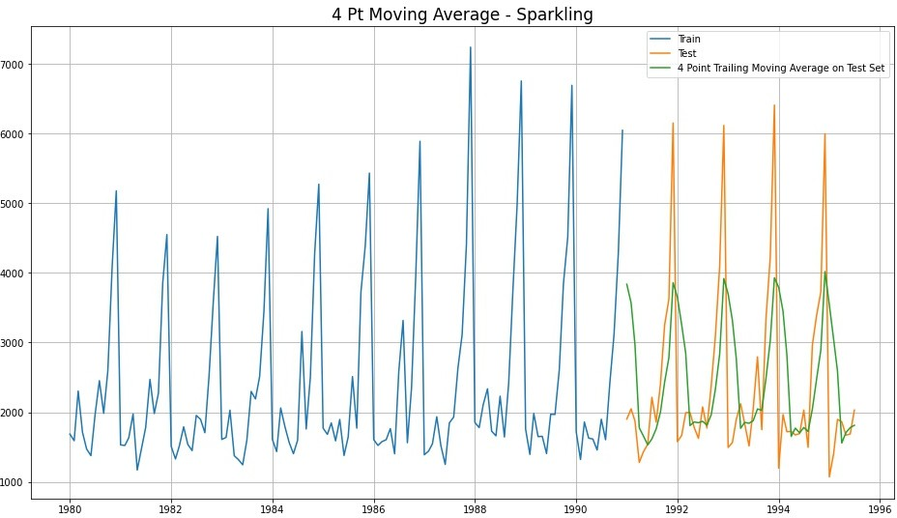

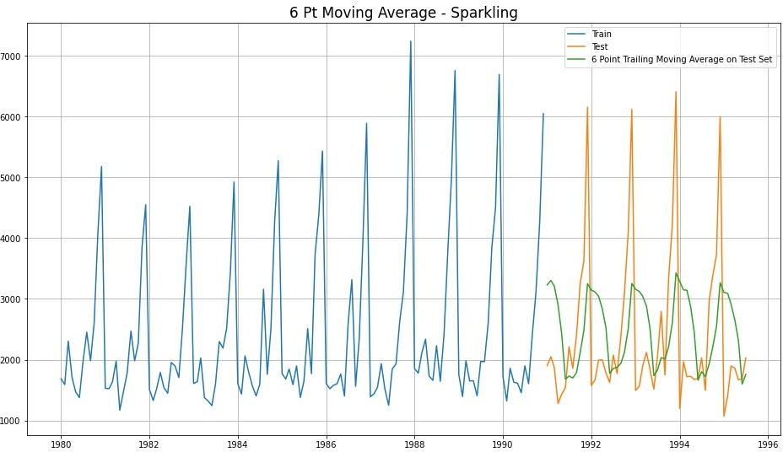

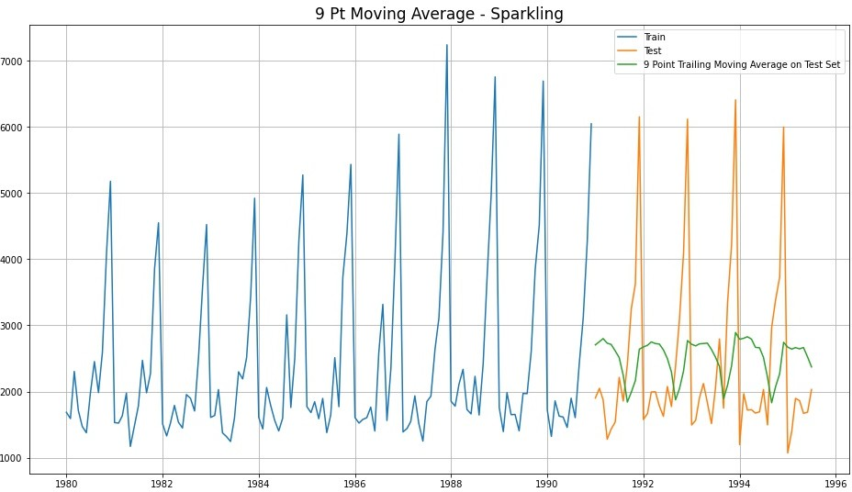

|  |  |
| --- | --- |
|  | Test RMSE Sparkling |
| **2pointTrailingMovingAverage** | 813.40 |
| **4pointTrailingMovingAverage** | 1156.59 |
| **6pointTrailingMovingAverage** | 1283.93 |
| **9pointTrailingMovingAverage** | 1346.28 |

Consolidated Moving Average Forecasts (Rose & Sparkling)

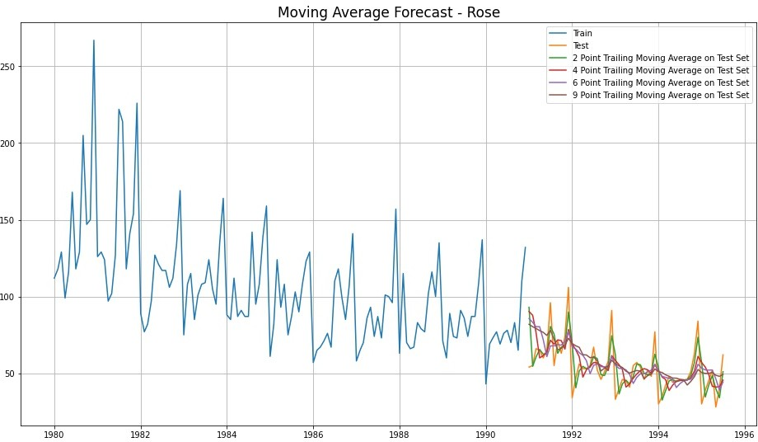

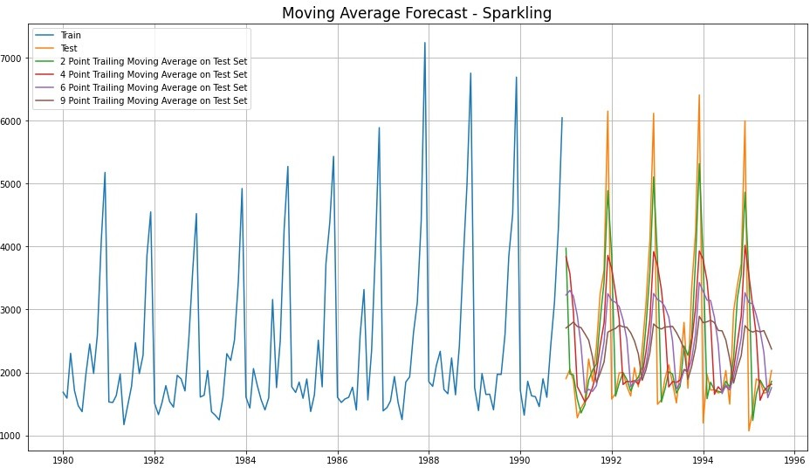

#### NOTE -

* We have built 4 models till now for both Rose and Sparkling Wine datasets
* We fitted various models to the Train split and Tested it on Test split. Accuracy metrics used is Root Mean Squared Error (RMSE) on Test data
* Model 1 - Linear Regression (*yt* = *β*0 + *β*1*Xt* + *ϵt*)
  + We regressed variables ‘Rose’ and ‘Sparkling’ against their individual time instances
  + We modified the datasets and tagged individual sales to their time instances
  + TEST RMSE ROSE = 15.27 | TEST RMSE SPARKLING = 1389.14
* Model 2 - Naive Approach (*yt*̂ +1 = *yt*)
  + Naive approach says that prediction for tomorrow is same as today
  + And, prediction for day-after is same as tomorrow
  + So, effectively all future predictions are going to be same as today
  + TEST RMSE ROSE = 79.72 | TEST RMSE SPARKLING = 3864.28
* Model 3 - Simple Average (*yt*̂ +1 = *yt*̂ +2 = . . . = *yt*̂ +*n* = *Mean*(*y*1, *y*2, . . . , *yt*))
  + All future predictions are the same as the simple average of all data till today
  + TEST RMSE ROSE = 53.46 | TEST RMSE SPARKLING = 1275.08
* Model 4 - Moving Average (MA)
  + We calculate rolling means (Moving averages) over different intervals for the whole train data
  + 2 Pt MA ====> means, we find average of 1st and 2nd to predict 3rd similarly, average of 2nd and 3rd to predict 4th and so on
  + 4 Pt MA ====> means, we find average of 1st, 2nd, 3rd & 4th to predict 5th also, average of 2nd, 3rd, 4th & 5th to predict 6th and so on
  + 2 PT MA ====>

TEST RMSE ROSE = 11.53 | TEST RMSE SPARKLING = 813.40

* + 4 PT MA ====>

TEST RMSE ROSE = 14.45 | TEST RMSE SPARKLING = 1156.59

* + 6 PT MA ====>

TEST RMSE ROSE = 14.57 | TEST RMSE SPARKLING = 1283.93

* + 9 PT MA ====>

TEST RMSE ROSE = 14.73 | TEST RMSE SPARKLING = 1346.28

|  |  |  |
| --- | --- | --- |
|  | Test RMSE Rose | **Test RMSE Sparkling** |
| **RegressionOnTime** | 15.27 | 1389.14 |
| **NaiveModel** | 79.72 | 3864.28 |
| **SimpleAverageModel** | 53.46 | 1275.08 |
| **2pointTrailingMovingAverage** | **11.53** | **813.40** |
| **4pointTrailingMovingAverage** | 14.45 | 1156.59 |
| **6pointTrailingMovingAverage** | 14.57 | 1283.93 |
| **9pointTrailingMovingAverage** | 14.73 | 1346.28 |

Consolidated Scores of Regression, Naive, Simple Average & Moving Average

* Till now, Best Model which gives lowest RMSE score for both Rose and Sparkling is ——> 2 Pt Moving Average Model
* We’ll continue to forecast using Exponential Smoothing Models for both datasets of Rose and Sparkling Wine Sales
* Exponential smoothing averages or exponentially weighted moving averages consist of forecast based on previous periods data with exponentially declining influence on the older observations
* Exponential smoothing methods consist of special case exponential moving with notation ETS (Error, Trend, Seasonality) where each can be None(N), Additive (N), Additive damped (Ad), Multiplicative (M) or Multiplicative damped (Md)
* One or more parameters control how fast the weights decay. The values of the parameters lie between 0 and 1
* We’ll build following Exponential Smoothing Models -
  + Single Exponential Smoothing with Additive Errors - ETS(A, N, N)
  + Double Exponential Smoothing with Additive Errors, Additive Trends -

ETS(A, A, N)

* + Triple Exponential Smoothing with Additive Errors, Additive Trends, Additive Seasonality - ETS(A, A, A)
  + Triple Exponential Smoothing with Additive Errors, Additive Trends, Multiplicative Seasonality - ETS(A, A, M)
  + Triple Exponential Smoothing with Additive Errors, Additive DAMPED

Trends, Additive Seasonality - ETS(A, Ad, A)

* + Triple Exponential Smoothing with Additive Errors, Additive DAMPED

Trends, Multiplicative Seasonality - ETS(A, Ad, M)

#### Single Exponential Smoothing with Additive Errors - ETS(A, N, N)

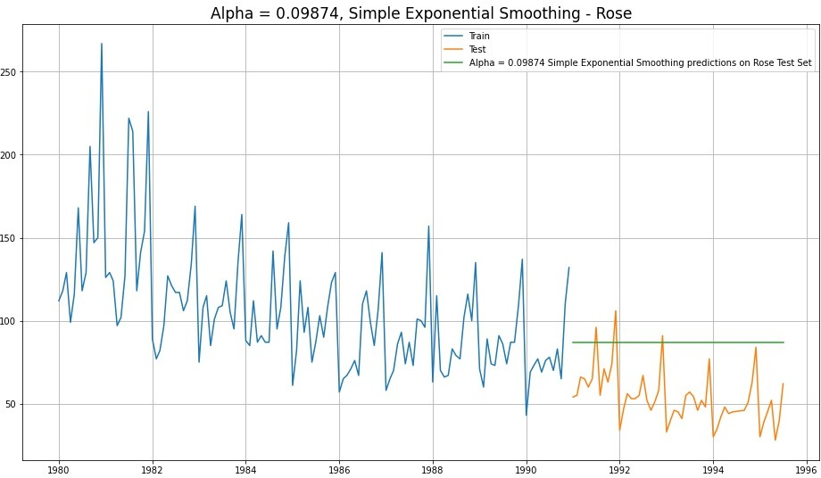

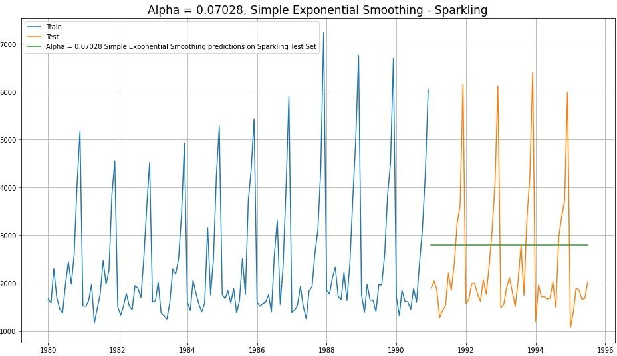

* + - For Rose - Level Parameter, Alpha = 0.09874
    - For Sparkling - Level Parameter, Alpha = 0.07028

|  |  |  |
| --- | --- | --- |
|  | Test RMSE Rose | **Test RMSE Sparkling** |
| **RegressionOnTime** | 15.27 | 1389.14 |
| **NaiveModel** | 79.72 | 3864.28 |
| **SimpleAverageModel** | 53.46 | 1275.08 |
| **2pointTrailingMovingAverage** | **11.53** | **813.40** |
| **4pointTrailingMovingAverage** | 14.45 | 1156.59 |
| **6pointTrailingMovingAverage** | 14.57 | 1283.93 |
| **9pointTrailingMovingAverage** | 14.73 | 1346.28 |
| **Simple Exponential Smoothing** | 36.80 | 1338.00 |

* Best Model till now for Rose and Sparkling ——- > 2 Pt Moving Average Model

#### Double Exponential Smoothing with Additive Errors, Additive Trends - ETS(A, A, N)

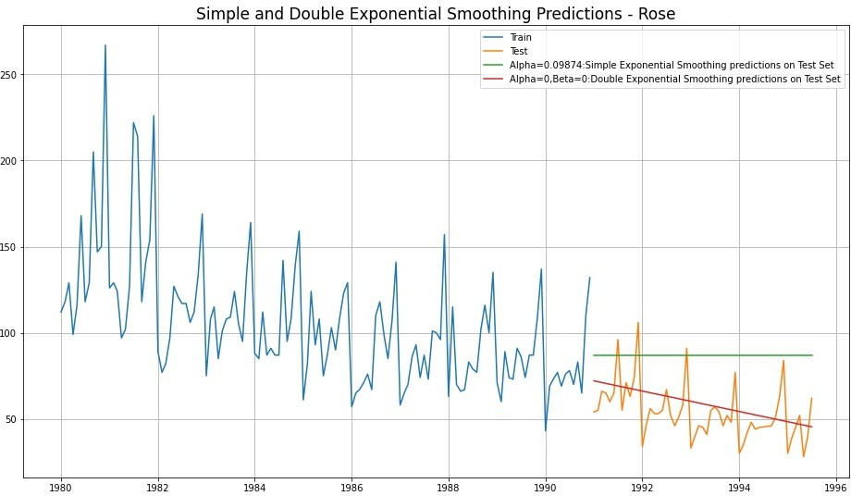

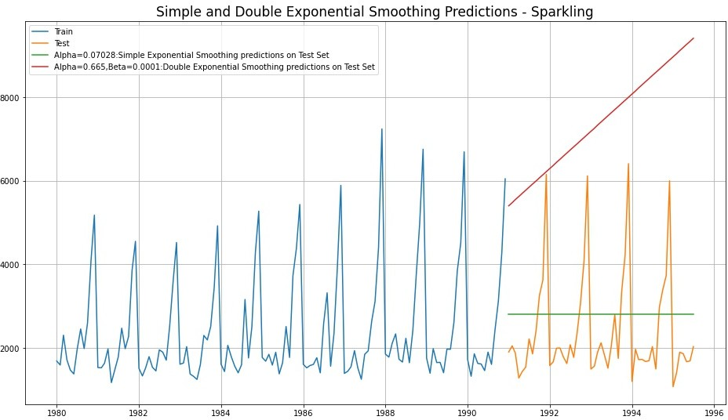

* In Rose - DES has picked up the trend well. DES seems to perform better than SES here
* In Sparkling - DES shows a non-existent trend. DES does not perform well here
* Rose - Level parameter, Alpha = 0 Trend parameter, Beta = 0
* Sparkling - Level parameter, Alpha = 0.665 Trend parameter, Beta = 0.0001

|  |  |  |
| --- | --- | --- |
|  | Test RMSE Rose | **Test RMSE Sparkling** |
| **RegressionOnTime** | 15.27 | 1389.14 |
| **NaiveModel** | 79.72 | 3864.28 |
| **SimpleAverageModel** | 53.46 | 1275.08 |
| **2pointTrailingMovingAverage** | **11.53** | **813.40** |
| **4pointTrailingMovingAverage** | 14.45 | 1156.59 |
| **6pointTrailingMovingAverage** | 14.57 | 1283.93 |
| **9pointTrailingMovingAverage** | 14.73 | 1346.28 |
| **Simple Exponential Smoothing** | 36.80 | 1338.00 |
| **Double Exponential Smoothing** | 15.27 | 5291.88 |

* Best Model till now for Rose and Sparkling ——- > 2 Pt Moving Average Model

#### Triple Exponential Smoothing with Additive Errors, Additive Trends, Additive Seasonality - ETS(A, A, A)

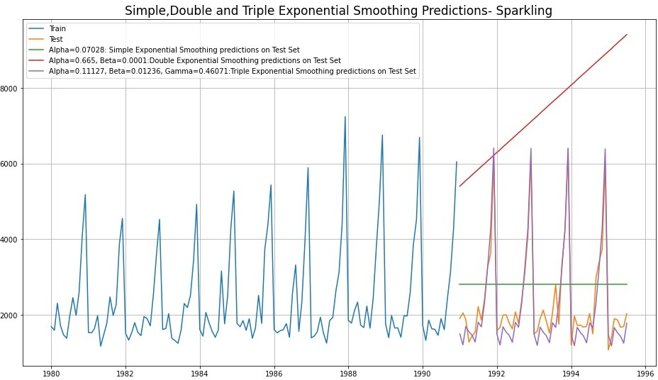

* In Rose & Sparkling - TES has picked up the trend and seasonality very well
* Rose - Level parameter, Alpha = 0.0849 Trend parameter, Beta = 0.0

Seasonality parameter, Gamma = 0.00054

* Sparkling - Level parameter, Alpha = 0.11127 Trend parameter, Beta = 0.01236

Seasonality parameter, Gamma = 0.46071

|  |  |  |
| --- | --- | --- |
|  | Test RMSE Rose | **Test RMSE Sparkling** |
| **RegressionOnTime** | 15.27 | 1389.14 |
| **NaiveModel** | 79.72 | 3864.28 |
| **SimpleAverageModel** | 53.46 | 1275.08 |
| **2pointTrailingMovingAverage** | **11.53** | 813.40 |
| **4pointTrailingMovingAverage** | 14.45 | 1156.59 |
| **6pointTrailingMovingAverage** | 14.57 | 1283.93 |
| **9pointTrailingMovingAverage** | 14.73 | 1346.28 |
| **Simple Exponential Smoothing** | 36.80 | 1338.00 |
| **Double Exponential Smoothing** | 15.27 | 5291.88 |
| **Triple Exponential Smoothing (Additive Season)** | 14.24 | **378.63** |

* Till now, Best Model for Rose ——> 2 Pt Moving Average

Best Model for Sparkling ——> Holt-Winter - ETS (A, A, A)

#### Triple Exponential Smoothing with Additive Errors, Additive Trends, Multiplicative Seasonality - ETS(A, A, M)

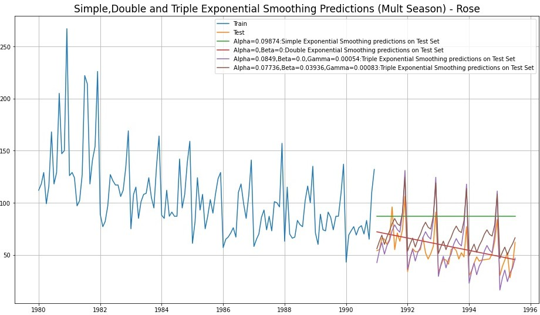

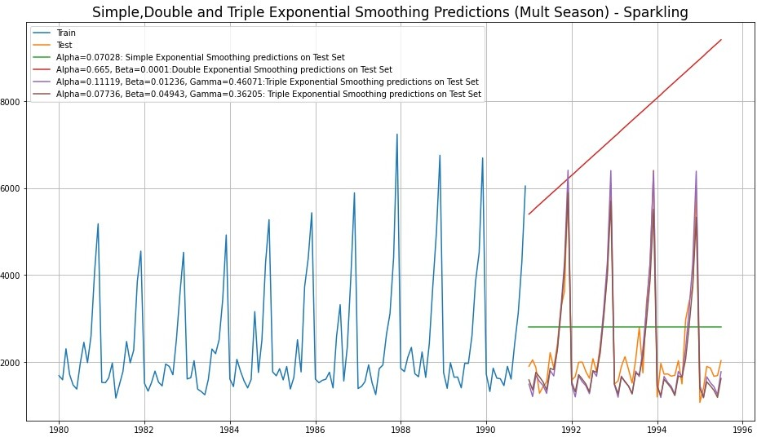

* Rose - Level parameter, Alpha = 0.07736 Trend parameter, Beta = 0.03936

Seasonality parameter, Gamma = 0.00083

* Sparkling - Level parameter, Alpha = 0.07736 Trend parameter, Beta = 0.04943

Seasonality parameter, Gamma = 0.36205

|  |  |  |
| --- | --- | --- |
|  | Test RMSE Rose | **Test RMSE Sparkling** |
| **RegressionOnTime** | 15.27 | 1389.14 |
| **NaiveModel** | 79.72 | 3864.28 |
| **SimpleAverageModel** | 53.46 | 1275.08 |
| **2pointTrailingMovingAverage** | **11.53** | 813.40 |
| **4pointTrailingMovingAverage** | 14.45 | 1156.59 |
| **6pointTrailingMovingAverage** | 14.57 | 1283.93 |
| **9pointTrailingMovingAverage** | 14.73 | 1346.28 |
| **Simple Exponential Smoothing** | 36.80 | 1338.00 |
| **Double Exponential Smoothing** | 15.27 | 5291.88 |
| **Triple Exponential Smoothing (Additive Season)** | 14.24 | **378.63** |
| **Triple Exponential Smoothing (Multiplicative Season)** | 19.11 | 403.71 |

* Till now, Best Model for Rose ——> 2 Pt Moving Average

Best Model for Sparkling ——> Holt-Winter - ETS (A, A, A)

#### Triple Exponential Smoothing with Additive Errors, Additive DAMPED Trends, Additive Seasonality - ETS(A, Ad, A)

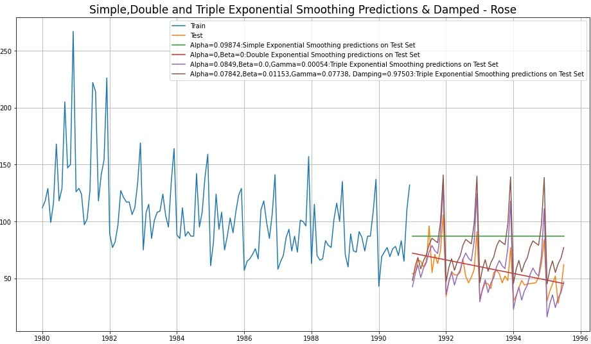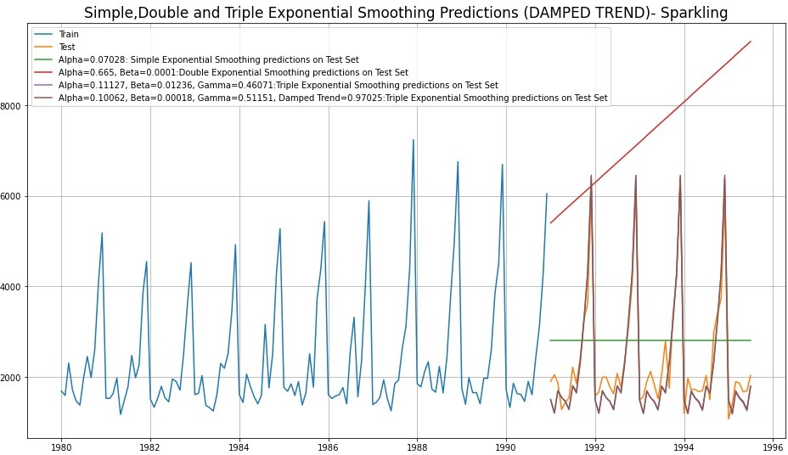

* Rose - Level parameter, Alpha = 0.07842 Trend parameter, Beta = 0.01153

Seasonality parameter, Gamma = 0.07738

Damping factor = 0.97503

* Sparkling - Level parameter, Alpha = 0.10062 Trend parameter, Beta = 0.00018

Seasonality parameter, Gamma = 0.97025 Damping factor = 0.97025

|  |  |  |
| --- | --- | --- |
|  | Test RMSE Rose | **Test RMSE Sparkling** |
| **RegressionOnTime** | 15.27 | 1389.14 |
| **NaiveModel** | 79.72 | 3864.28 |
| **SimpleAverageModel** | 53.46 | 1275.08 |
| **2pointTrailingMovingAverage** | **11.53** | 813.40 |
| **4pointTrailingMovingAverage** | 14.45 | 1156.59 |
| **6pointTrailingMovingAverage** | 14.57 | 1283.93 |
| **9pointTrailingMovingAverage** | 14.73 | 1346.28 |
| **Simple Exponential Smoothing** | 36.80 | 1338.00 |
| **Double Exponential Smoothing** | 15.27 | 5291.88 |
| **Triple Exponential Smoothing (Additive Season)** | 14.24 | **378.63** |
| **Triple Exponential Smoothing (Multiplicative Season)** | 19.11 | 403.71 |
| **Triple Exponential Smoothing (Additive Season, Damped Trend)** | 26.04 | 378.63 |

* Till now, Best Model for Rose ——> 2 Pt Moving Average

Best Model for Sparkling ——> Holt-Winter - ETS (A, A, A)

#### Triple Exponential Smoothing with Additive Errors, Additive DAMPED Trends, Multiplicative Seasonality - ETS(A, Ad, M)

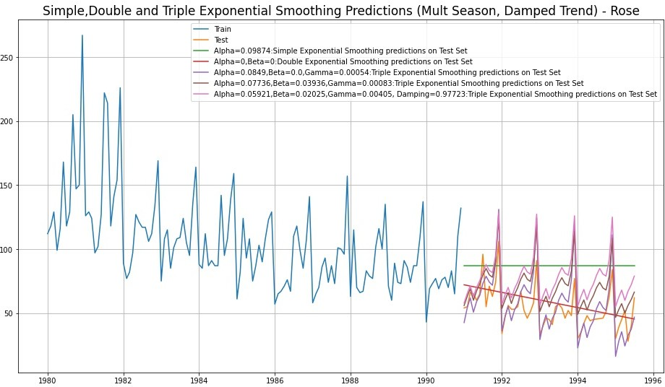

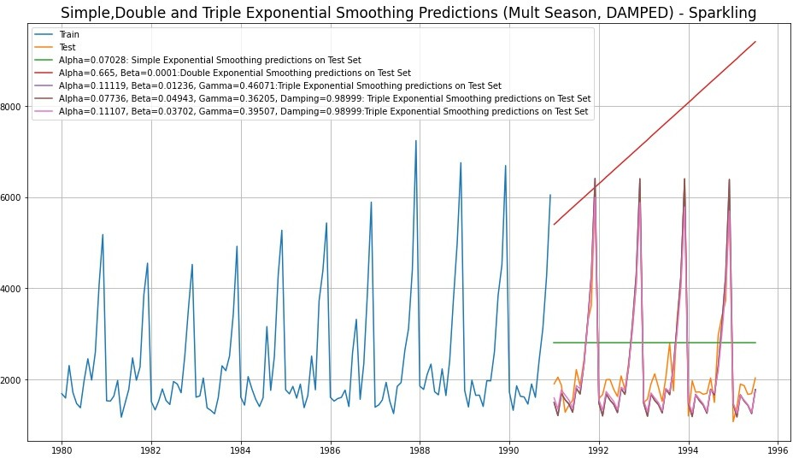

* Rose - Level parameter, Alpha = 0.05921 Trend parameter, Beta = 0.02025

Seasonality parameter, Gamma = 0.00405 Damping factor = 0.97723

* Sparkling - Level parameter, Alpha = 0.11107 Trend parameter, Beta = 0.03702

Seasonality parameter, Gamma = 0.39507 Damping factor = 0.98999

|  |  |  |
| --- | --- | --- |
|  | Test RMSE Rose | **Test RMSE Sparkling** |
| **RegressionOnTime** | 15.27 | 1389.14 |
| **NaiveModel** | 79.72 | 3864.28 |
| **SimpleAverageModel** | 53.46 | 1275.08 |
| **2pointTrailingMovingAverage** | **11.53** | 813.40 |
| **4pointTrailingMovingAverage** | 14.45 | 1156.59 |
| **6pointTrailingMovingAverage** | 14.57 | 1283.93 |
| **9pointTrailingMovingAverage** | 14.73 | 1346.28 |
| **Simple Exponential Smoothing** | 36.80 | 1338.00 |
| **Double Exponential Smoothing** | 15.27 | 5291.88 |
| **Triple Exponential Smoothing (Additive Season)** | 14.24 | 378.63 |
| **Triple Exponential Smoothing (Multiplicative Season)** | 19.11 | 403.71 |
| **Triple Exponential Smoothing (Additive Season, Damped Trend)** | 26.04 | 378.63 |
| **Triple Exponential Smoothing (Multiplicative Season, Damped Trend)** | 25.99 | **352.45** |

* We conclude that models with least RMSE,

Best Model for Rose ——> 2 Pt Moving Average

Best Model for Sparkling ——> Holt-Winter Damped Trend

ETS (A, Ad, M)

Best Models for Rose and Sparkling -

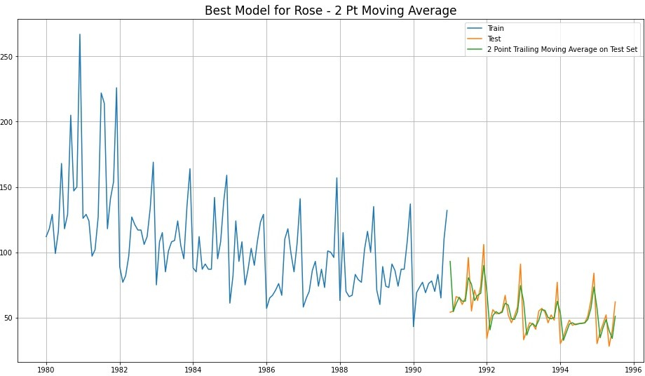

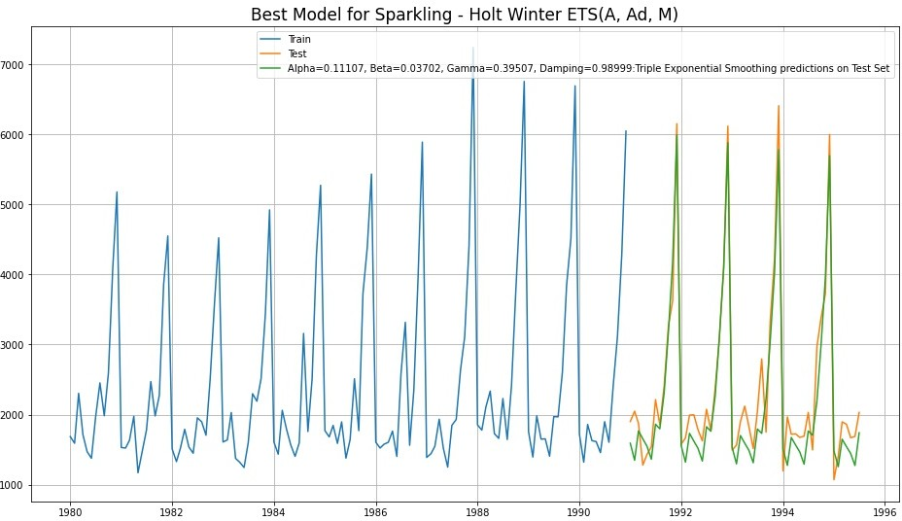

## 5) Check for the stationarity of the data on which the model is being built on using appropriate statistical tests and also mention the hypothesis for the statistical test.

#### To Check Stationarity of Data -

* We use Augmented Dicky - Fuller (ADF) Test to check the Stationarity of Data
* Hypotheses of ADF Test :

*H*0 *Time Series is not Stationary*

*Ha Time Series is Stationary*

* So for Industry standard (also given for this problem), the Confidence Interval is 95%
* Hence, alpha = 0.05
* So in ADF Test, if p-value < alpha ===> We reject the Null Hypothesis and hence

conclude that given Time Series is Stationary

* So in ADF Test, if p-value > alpha ===> We fail to reject the Null Hypothesis and

hence conclude that given Time Series is Not Stationary

* If Time Series is not Stationary then we apply one level of differencing and check for Stationarity again.
* Again, if the Time Series is still not Stationary, we apply one more level of differencing and check for Stationarity again
* Generally, with max 2 levels of differencing, Time Series becomes Stationary
* Once the Time Series is Stationary then we are ready to apply ARIMA / SARIMA models

#### Stationarity of Rose Wine Dataset -

* Augmented Dicky-Fuller Test was applied to the whole Rose dataset
* We found, p-value = 0.4671
* Here, p-value > alpha=0.05
* We fail to reject the Null Hypothesis and hence conclude that Rose Wine Time Series is Not Stationary
* We take 1 level of differencing and check again for Stationarity
* Now, p-value = 3.0159e-11 0.00
* Now, p-value < alpha=0.05
* Now, we reject the Null Hypothesis and conclude that Rose Time Series is Stationary with a lag of 1

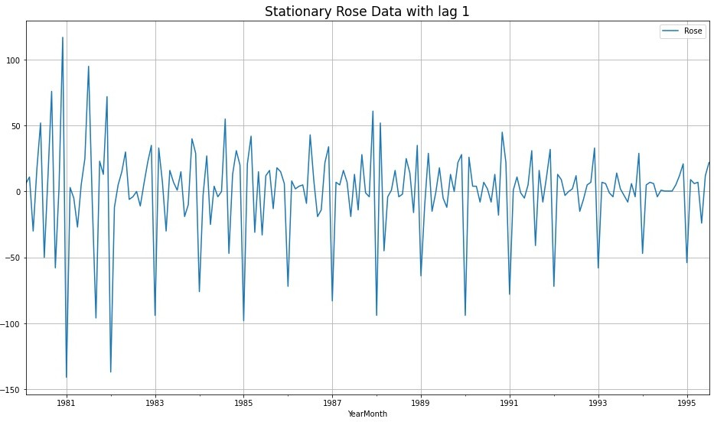

#### Stationarity of Sparkling Wine Dataset -

* Augmented Dicky-Fuller Test was applied to the whole Sparkling dataset
* We found, p-value = 0.70559
* Here, p-value > alpha=0.05
* We fail to reject the Null Hypothesis and hence conclude that Sparkling Wine Time Series is Not Stationary
* We take 1 level of differencing and check again for Stationarity
* Now, p-value = 0.00
* Now, p-value < alpha=0.05
* Now, we reject the Null Hypothesis and conclude that Sparkling Time Series is Stationary with a lag of 1

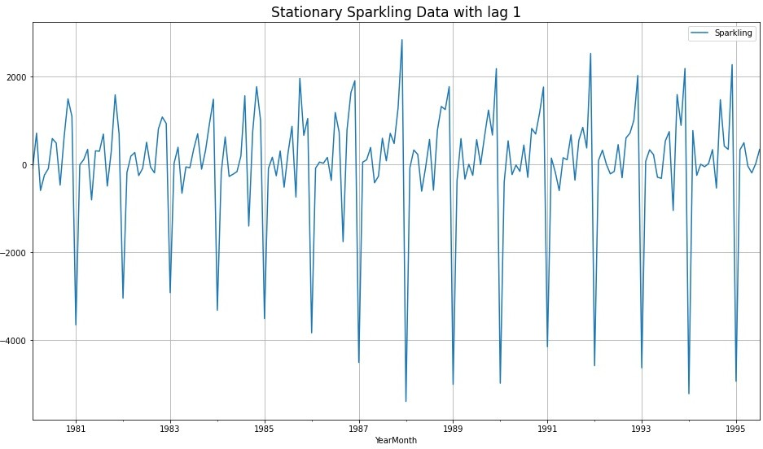

## 6) Build an automated version of the ARIMA/SARIMA model in which the parameters are selected using the lowest Akaike Information Criteria (AIC) on the training data and evaluate this model on the test data using RMSE

#### ARIMA / SARIMA Models -

* ARIMA is an acronym for Auto-Regressive Integrated Moving Average
* SARIMA stands for Seasonal ARIMA, when the TS has seasonality
* ARIMA / SARIMA are forecasting models on Stationary Time Series

#### ARIMA / SARIMA Modelling on Train Rose & Sparkling Data -

* We check for stationarity of Train Rose & Sparkling data by using Augmented Dicky Fuller Test
* We take a difference of 1 and make both these datasets Stationary
* We apply the following iterations to both these datasets -

1. ARIMA Automated
2. SARIMA Automated

#### ARIMA Automated -

* + We create a grid of all possible combinations of (p, d, q)
  + Range of p = Range of q = 0 to 3, Constant d = 1
  + Few Examples of the grid -

Model: (0, 1, 2)

Model: (0, 1, 3)

Model: (1, 1, 0)

Model: (1, 1, 1)

Model: (1, 1, 2)

Model: (1, 1, 3)

Model: (2, 1, 0)

Model: (2, 1, 1)

Model: (2, 1, 2)

Model: (2, 1, 3)

Model: (3, 1, 0)

Model: (3, 1, 1)

* + We fit ARIMA models to each of these combinations for both datasets
  + We choose the combination with the least Akaike Information Criteria (AIC)
  + We fit ARIMA to this combination of (p, d, q) to the Train set and forecast on the Test set
  + Finally, we check the accuracy of this model by checking RMSE of Test set
  + For Rose, Best Combination with Least AIC is - (p, d, q) —-> (2, 1, 3)

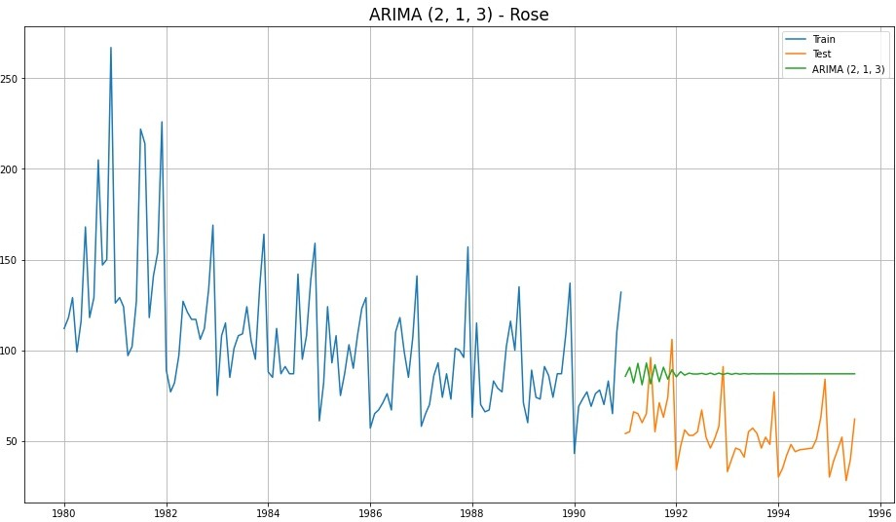

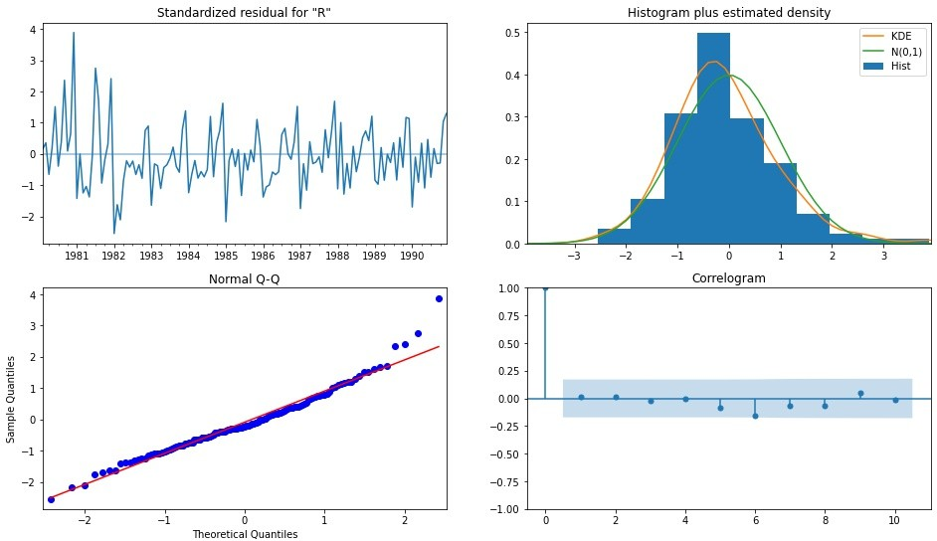ARIMA (2, 1, 3) Diagnostic Plot - Rose

|  |  |  |
| --- | --- | --- |
|  | Test RMSE Rose | **Test MAPE Rose** |
| **ARIMA(2,1,3)** | 36.81 | 75.84 |

* + For Sparkling, Best Combination with Least AIC is - (p, d, q) —-> (2, 1, 2)

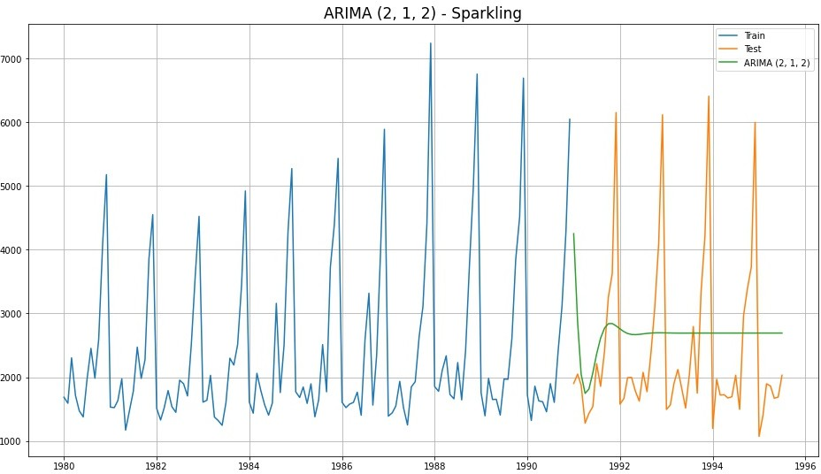

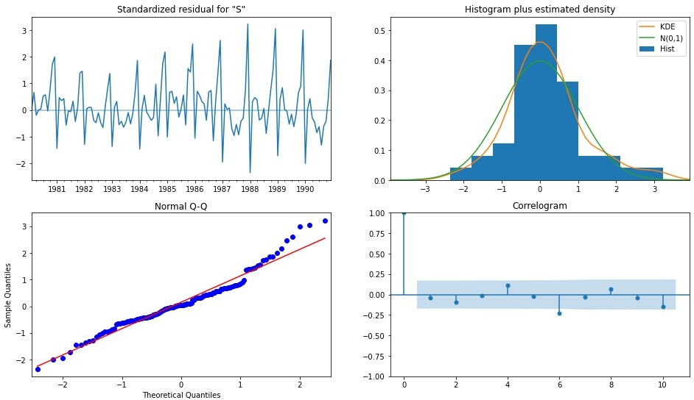ARIMA (2, 1, 2) Diagnostic Plot - Sparkling

|  |  |  |
| --- | --- | --- |
|  | Test RMSE Sparkling | **Test MAPE Sparkling** |
| **ARIMA(2,1,2)** | 1299.98 | 47.10 |

#### SARIMA Automated -

* + We create a grid of all possible combinations of (p, d, q) along with Seasonal (P, D, Q) & Seasonality of 12 (for both datasets)
  + Range of p = Range of q = 0 to 3, Constant d = 1
  + Range of Seasonal P = Range of Seasonal Q = 0 to 3, Constant D = 1, Seasonality m = 12
  + Few Examples of the grid (p, d, q) (P, D, Q, m) -

Model: (0, 1, 2)(0, 0, 2, 12)

Model: (0, 1, 3)(0, 0, 3, 12)

Model: (1, 1, 0)(1, 0, 0, 12)

Model: (1, 1, 1)(1, 0, 1, 12)

Model: (1, 1, 2)(1, 0, 2, 12)

Model: (1, 1, 3)(1, 0, 3, 12)

Model: (2, 1, 0)(2, 0, 0, 12)

Model: (2, 1, 1)(2, 0, 1, 12)

Model: (2, 1, 2)(2, 0, 2, 12)

Model: (2, 1, 3)(2, 0, 3, 12)

Model: (3, 1, 0)(3, 0, 0, 12)

* + We fit SARIMA models to each of these combinations and select with least AIC
  + We fit SARIMA to this best combination of (p, d, q) (P, D, Q, m) to the Train set and forecast on the Test set. Then, we check accuracy using RMSE on Test set
  + For Rose, Best Combination with Least AIC is - (3, 1, 1) (3, 0, 2, 12)

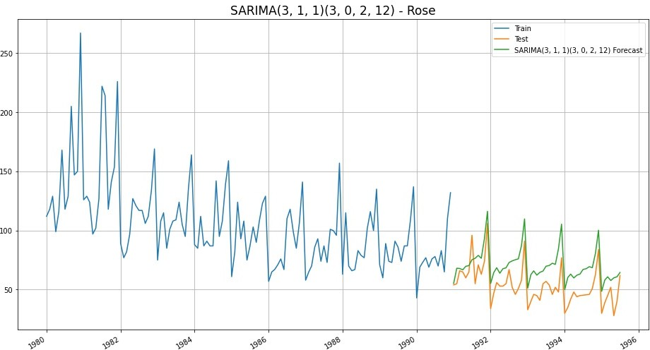

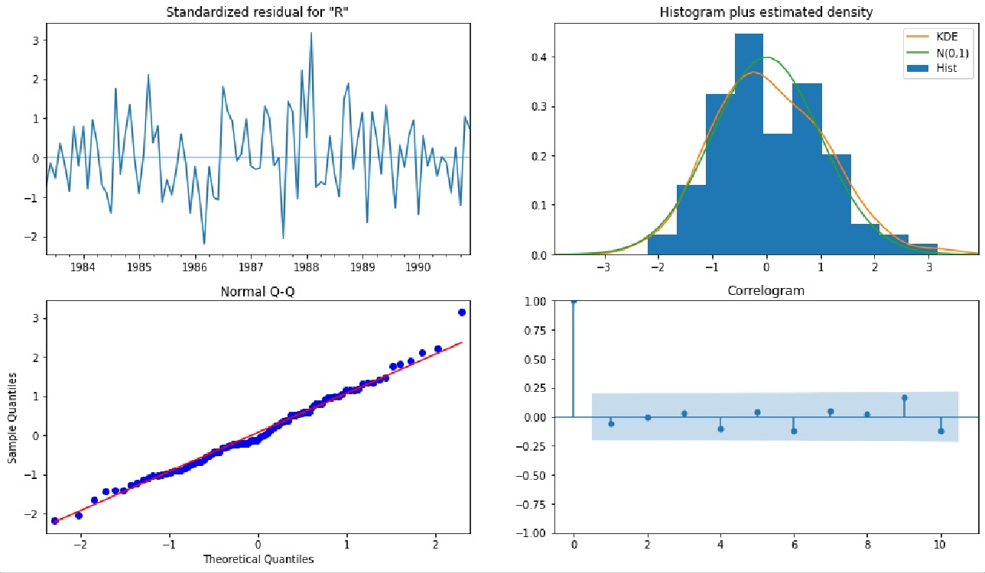SARIMA (3, 1, 1) (3, 0, 2, 12) Diagnostic Plot - ROSE

|  |  |  |
| --- | --- | --- |
|  | Test RMSE Rose | **Test MAPE Rose** |
| **ARIMA(2,1,3)** | 36.81 | 75.84 |
| **SARIMA (3, 1, 1) (3, 0, 2, 12)** | 18.88 | 36.38 |

* + For Sparkling, Best Combination with low AIC and low Test RMSE is -

(3, 1, 1) (3, 0, 0, 12)

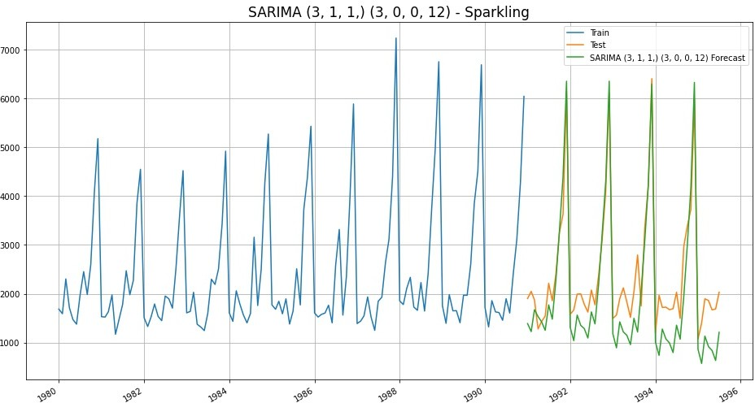

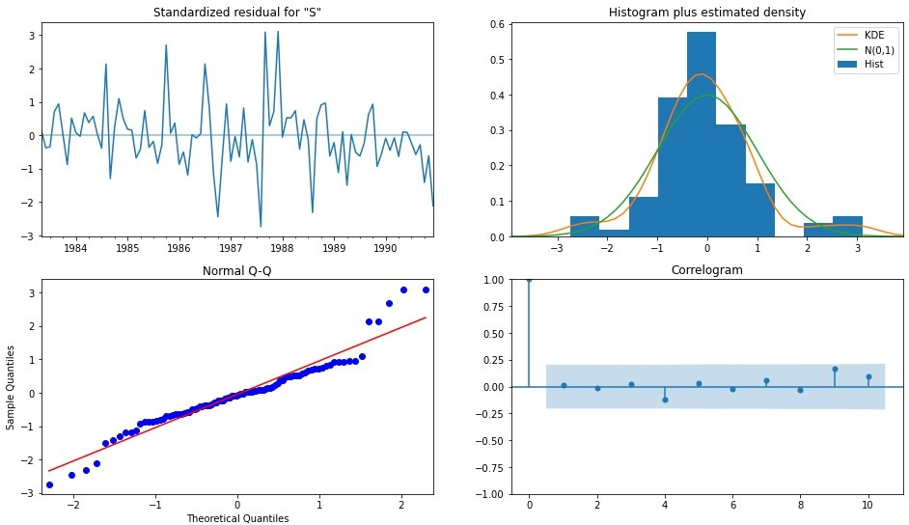SARIMA (3, 1, 1) (3, 0, 0, 12) Diagnostic Plot - SPARKLING

|  |  |  |
| --- | --- | --- |
|  | Test RMSE Sparkling | **Test MAPE Sparkling** |
| **ARIMA(2,1,2)** | 1299.98 | 47.10 |
| **SARIMA (3, 1, 1) (3, 0, 0, 12)** | 601.24 | 25.87 |

* + Till Now, Best Model for Rose with Least RMSE —-> SARIMA (3, 1, 1) (3, 0, 2, 12)
  + Till Now, Best Model for Sparkling with Least RMSE ->SARIMA (3, 1, 1) (3, 0, 0, 12)

## 7) Build ARIMA/SARIMA models based on the cut-off points of ACF and PACF on the training data and evaluate this model on the test data using RMSE.

#### Auto-Correlation Function (ACF) -

* + Autocorrelation refers to how correlated a time series is with its past values. e.g.

*yt* with *yt*−1 also *yt*+1 with *yt* and so on.

* + ‘Auto’ part of Autocorrelation refers to Correlation of any time instance with its previous time instance in the SAME Time Series
  + ACF is the plot used to see the correlation between the points, up to and including the lag unit
  + ACF indicates the value of ‘q’ - which is the Moving Average parameter in ARIMA / SARIMA models

#### Partial Auto-Correlation Function (PACF) -

* + Partial Autocorrelation refers to how correlated a time series is with its past lag values.
  + For example, let lag=k, then Partial Autocorrelation is Correlation of *yt* with *yt*−*k*, ignoring the effects of all the instances between *yt* and *yt*−*k*
  + PACF is the plot used to see the correlation between the lag points
  + PACF indicates the value of ‘p’ - which is the Auto-Regressive parameter in ARIMA / SARIMA models

#### ACF & PACF of Rose -

* + Observing the cutoffs in ACF and PACF plots for Rose dataset, we get - FOR ARIMA —-> p = 2, q = 2 and difference d = 1

FOR SARIMA —-> p = 2, q = 2, d = 1 and P = 2, D = 1, Q = 2, Seasonality=12

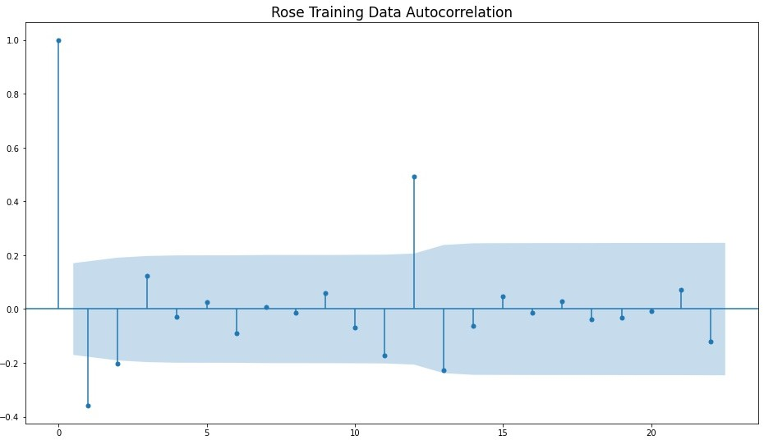

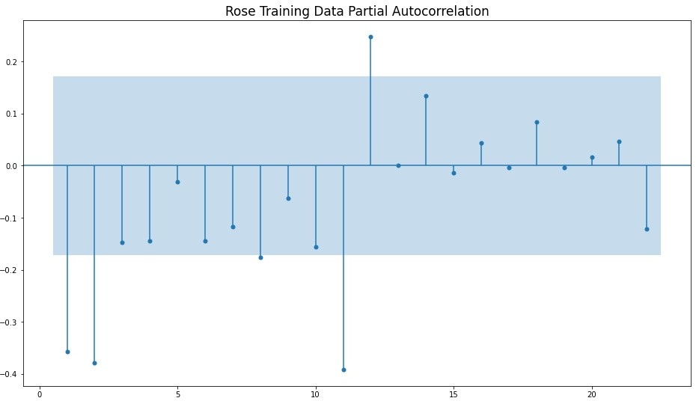

#### ACF & PACF of Sparkling -

* + Observing the cutoffs in ACF and PACF plots for Sparkling dataset, we get - FOR ARIMA —-> p = 0, q = 0 and difference d = 1

FOR SARIMA —-> p = 0, q = 0, d = 1 and P = 0, 1, 2, 3 | D = 0, Q = 1, 2, 3

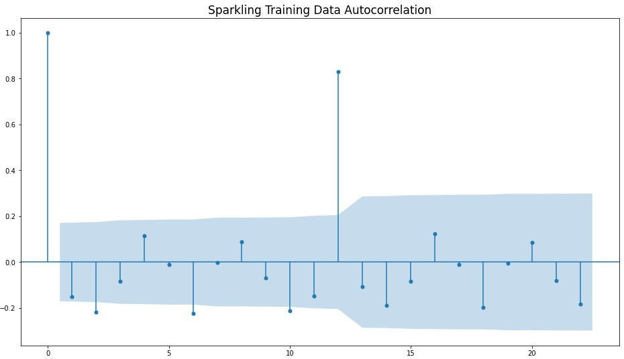

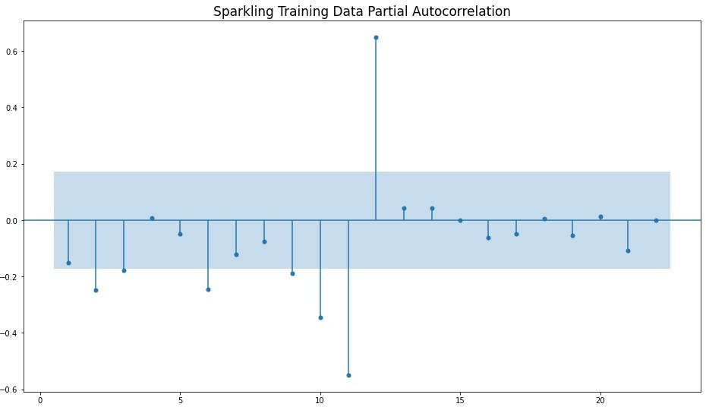

#### 1. ARIMA Manual - Rose - (2, 1, 2)

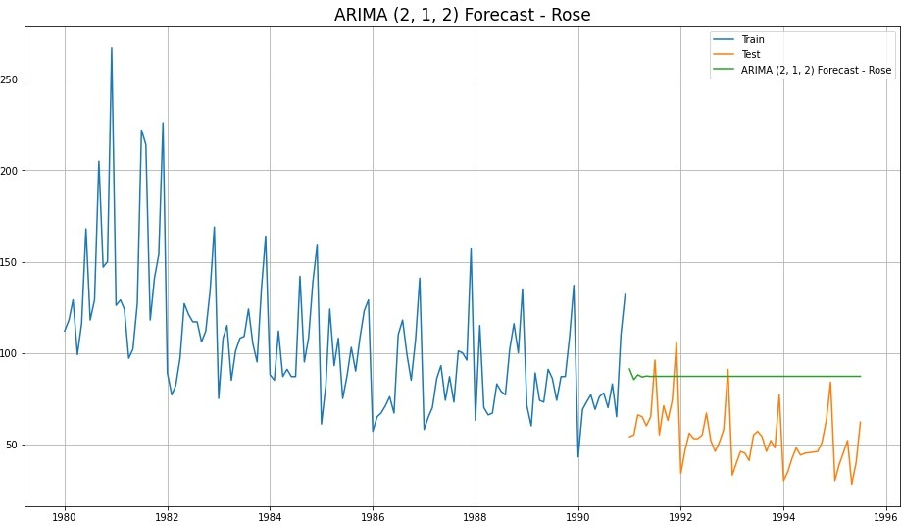

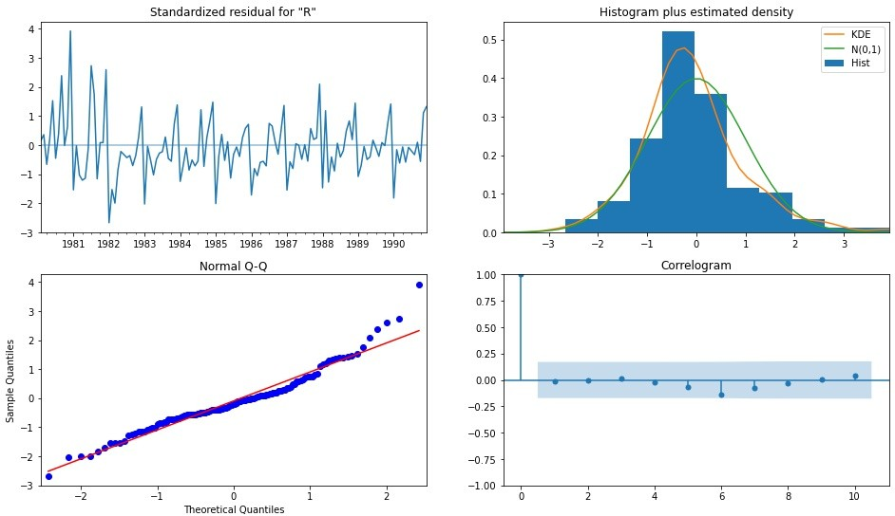ARIMA (2, 1, 2) Diagnostic Plot - ROSE

|  |  |  |
| --- | --- | --- |
|  | Test RMSE Rose | **Test MAPE Rose** |
| **ARIMA( 2, 1, 2)** | 36.87 | 76.06 |

#### 2. SARIMA Manual - Rose - (2, 1, 2) (2, 1, 2, 12)

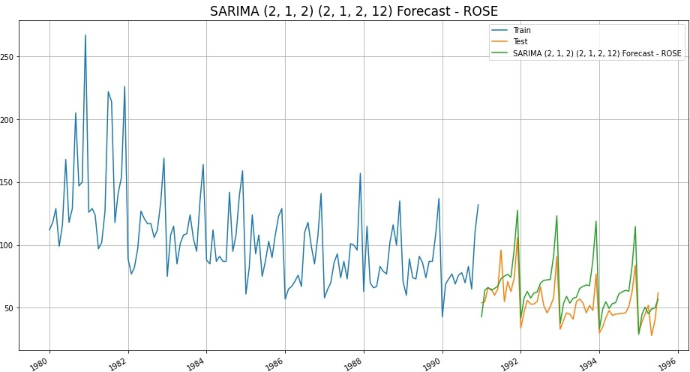

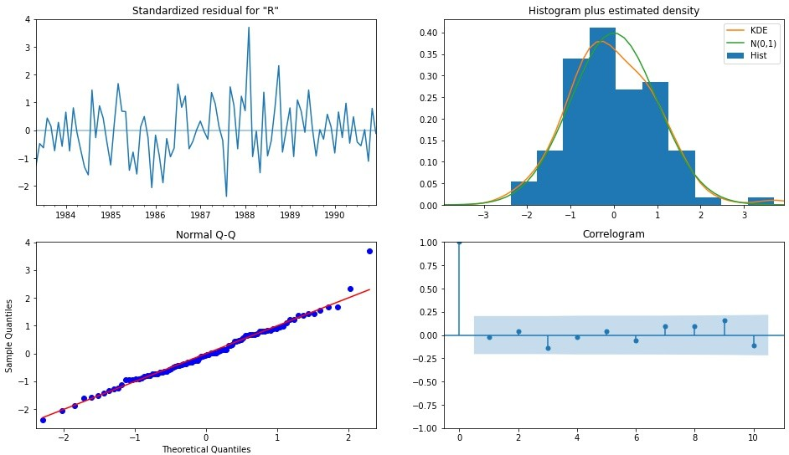

|  |  |  |
| --- | --- | --- |
|  | Test RMSE Rose | **Test MAPE Rose** |
| **ARIMA( 2, 1, 2)** | 36.87 | 76.06 |
| **SARIMA (2, 1, 2) (2, 1, 2, 12)** | 16.55 | 25.48 |

3. SARIMA Manual - Rose - (2, 1, 2) (3, 1, 2, 12)

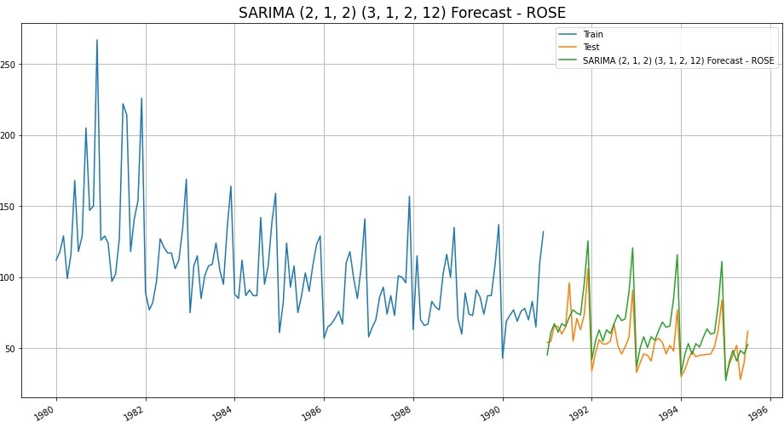

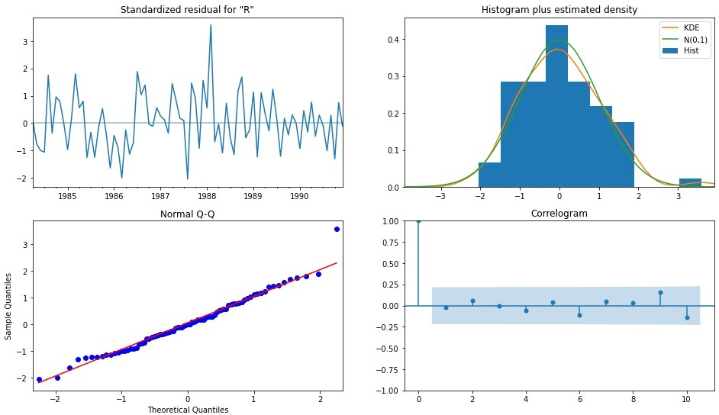

|  |  |  |
| --- | --- | --- |
|  | Test RMSE Rose | **Test MAPE Rose** |
| **ARIMA( 2, 1, 2)** | 36.87 | 76.06 |
| **SARIMA (2, 1, 2) (2, 1, 2, 12)** | 16.55 | 25.48 |
| **SARIMA (2, 1, 2) (3, 1, 2, 12)** | 15.36 | 22.96 |

#### ARIMA Manual - Sparkling - (0, 1, 0)

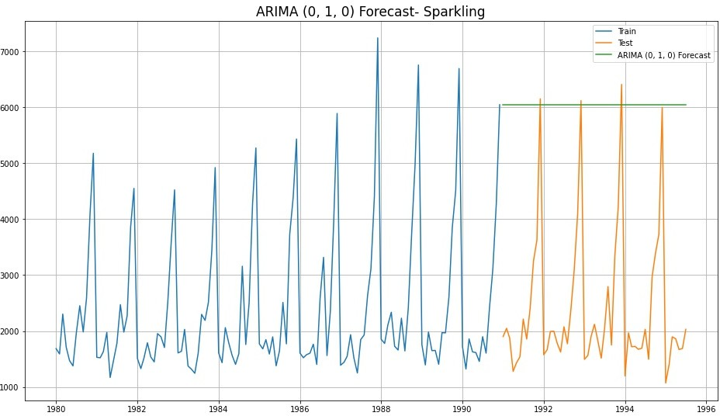

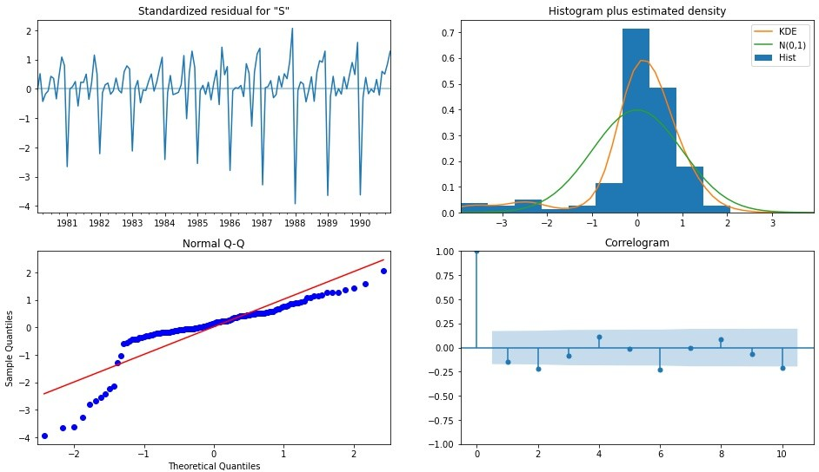

|  |  |  |
| --- | --- | --- |
|  | Test RMSE Sparkling | **Test MAPE Sparkling** |
| **ARIMA( 0, 1, 0)** | 3864.28 | 201.33 |

1. SARIMA Manual - Sparkling - (0, 1, 0) (1, 1, 1, 12)

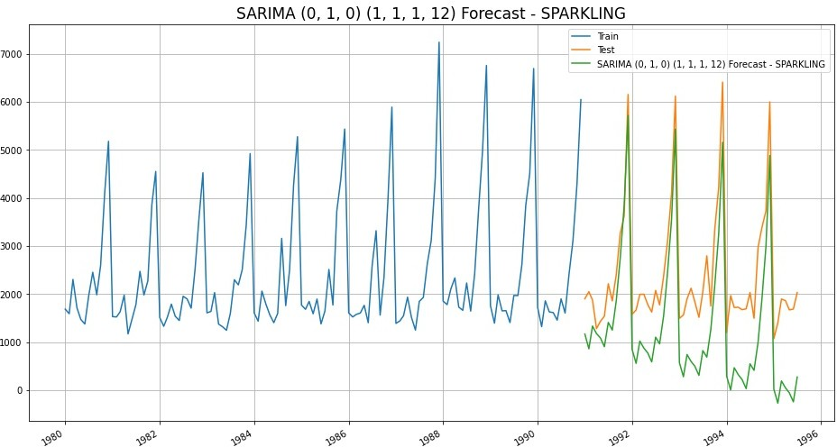

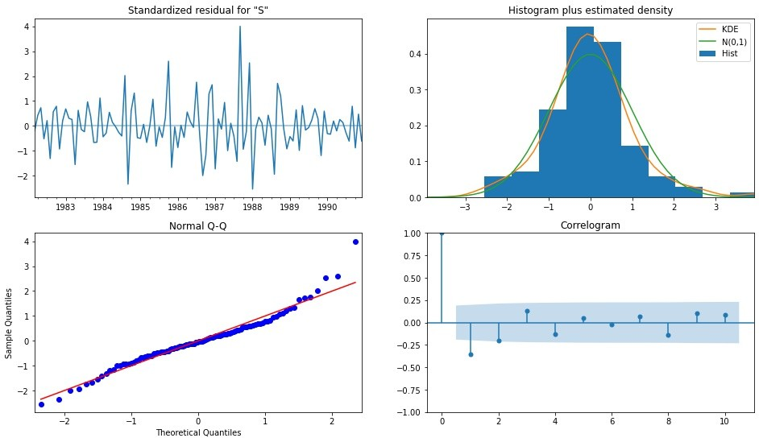

|  |  |  |
| --- | --- | --- |
|  | Test RMSE Sparkling | **Test MAPE Sparkling** |
| **ARIMA( 0, 1, 0)** | 3864.28 | 201.33 |
| **SARIMA (0, 1, 0) (1, 1, 1, 12)** | 1189.84 | 54.87 |

#### SARIMA Manual - Sparkling - (0, 1, 0) (2, 1, 2, 12)

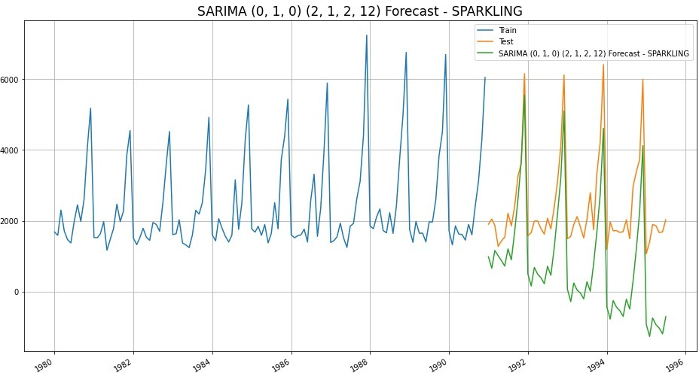

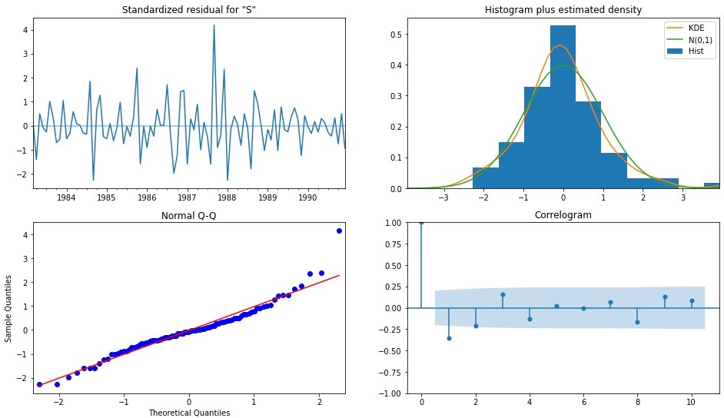

|  |  |  |
| --- | --- | --- |
|  | Test RMSE Sparkling | **Test MAPE Sparkling** |
| **ARIMA( 0, 1, 0)** | 3864.28 | 201.33 |
| **SARIMA (0, 1, 0) (1, 1, 1, 12)** | 1189.84 | 54.87 |
| **SARIMA (0, 1, 0) (2, 1, 2, 12)** | 1757.73 | 81.79 |

1. SARIMA Manual - Sparkling - (0, 1, 0) (3, 1, 2, 12)

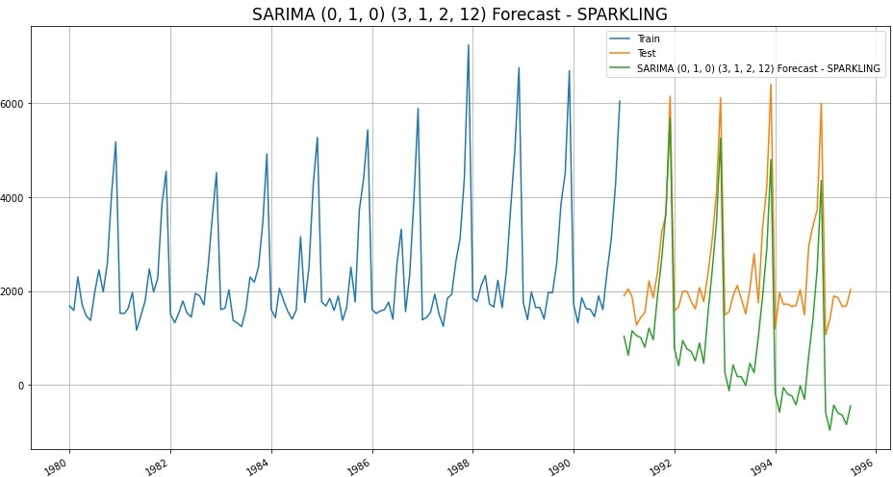

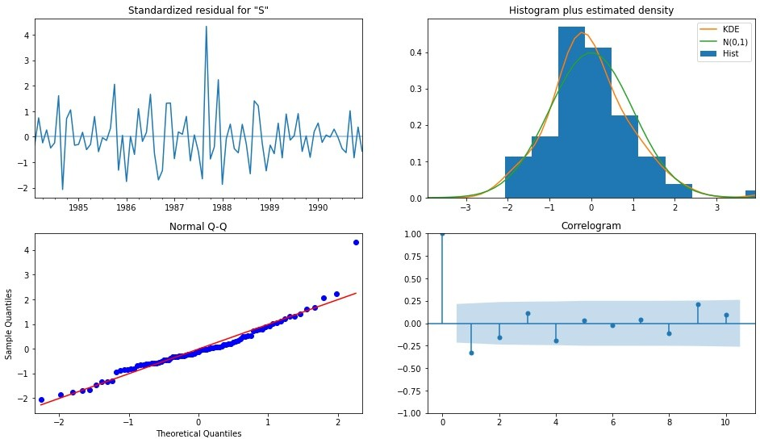SARIMA (0, 1, 0) (3, 1, 2, 12 Diagnostic Plot - SPARKLING

|  |  |  |
| --- | --- | --- |
|  | Test RMSE Sparkling | **Test MAPE Sparkling** |
| **ARIMA( 0, 1, 0)** | 3864.28 | 201.33 |
| **SARIMA (0, 1, 0) (1, 1, 1, 12)** | 1189.84 | 54.87 |
| **SARIMA (0, 1, 0) (2, 1, 2, 12)** | 1757.73 | 81.79 |
| **SARIMA (0, 1, 0) (3, 1, 2, 12)** | 1551.65 | 71.57 |

* + In all Manual methods, Best Model for Rose with Least RMSE

—-> SARIMA (2, 1, 2) (3, 1, 2, 12)

* + In all Manual methods, Best Model for Sparkling with Least RMSE

—-> SARIMA (0, 1, 0) (1, 1, 1, 12)

* + Seasonal P and Q - it was difficult to gauge the correct values here as the data was not enough and cutoffs were not visible
  + Hence, we tried multiple combinations of Seasonal P and Q as given above

## 8) Build a table (create a data frame) with all the models built along with their corresponding parameters and the respective RMSE values on the test data.

#### All Models built with ROSE (sorted by RMSE) -

|  |  |  |
| --- | --- | --- |
| **Model** | **Parameters** | **Test RMSE Rose** |
| **2pointTrailingMovingAverage** |  | 11.53 |
| **Triple Exponential Smoothing (Additive Season)** | *β* = 5.52*e*−6 ≈ 0.00  *γ* = 0.00054 | 14.24 |
| **4pointTrailingMovingAverage** |  | 14.45 |
| **6pointTrailingMovingAverage** |  | 14.57 |
| **9pointTrailingMovingAverage** |  | 14.73 |
| **RegressionOnTime** |  | 15.27 |
| **Double Exponential Smoothing** | *α* = 1.49*e*−8 ≈ 0.00  *β* = 5.488*e*−9 ≈ 0.0 | 15.27 |
| **SARIMA(2,1,2)(3,1,2,12)** |  | 15.36 |
| **SARIMA(3, 1, 1)(3, 0, 2, 12)** |  | 18.88 |
| **Triple Exponential Smoothing (Multiplicative Season)** | *β* = 0.03936  *γ* = 0.00083 | 19.11 |
| **Triple Exponential Smoothing (Multiplicative Season, Damped Trend)** | *α*  *β* = 0.0205  *γ* = 0.00405 | 25.99 |
| **Triple Exponential Smoothing (Additive Season, Damped Trend)** | *β* = 0.01153  *γ* = 0.07738 | 26.04 |
| **Simple Exponential Smoothing** |  | 36.80 |
| **ARIMA(2,1,3)** |  | 36.81 |
| **ARIMA(2,1,2)** |  | 36.87 |
| **SimpleAverageModel** |  | 53.46 |
| **NaiveModel** |  | 79.72 |

All Models built with SPARKLING (sorted by RMSE) -

|  |  |  |
| --- | --- | --- |
| **Model** | **Parameters** | **Test RMSE Sparkling** |
| **Triple Exponential Smoothing (Multiplicative Season, Damped Trend)** | *β* = 0.03702  *γ* = 0.39507 | 352.45 |
| **Triple Exponential Smoothing (Additive Season)** | *β* = 0.01236  *γ* = 0.4607 | 378.63 |
| **Triple Exponential Smoothing (Additive Season, Damped Trend)** | *β* = 0.00018  *γ* = 0.5115 | 378.63 |
| **Triple Exponential Smoothing (Multiplicative Season)** | *β* = 0.04943  *γ* = 0.36205 | 403.71 |
| **SARIMA(3,1,1)(3,0,2,12)** |  | 601.24 |
| **2pointTrailingMovingAverage** |  | 813.40 |
| **4pointTrailingMovingAverage** |  | 1156.59 |
| **SARIMA(0,1,0)(3,1,2,12)** |  | 1189.84 |
| **SimpleAverageModel** |  | 1275.08 |
| **6pointTrailingMovingAverage** |  | 1283.93 |
| **ARIMA(2,1,2)** |  | 1299.98 |
| **Simple Exponential Smoothing** |  | 1338.00 |
| **9pointTrailingMovingAverage** |  | 1346.28 |
| **RegressionOnTime** |  | 1389.14 |
| **SARIMA(0,1,0)(3,1,2,12)** |  | 1551.65 |
| **SARIMA(0,1,0)(2,1,2,12)** |  | 1757.73 |
| **NaiveModel** |  | 3864.28 |
| **ARIMA(0,1,0)** |  | 3864.28 |
| **Double Exponential Smoothing** | *α*  *β* = 0.000 | 5291.88 |

## 9) Based on the model-building exercise, build the most optimum model(s) on the complete data and predict 12 months into the future with appropriate confidence intervals/bands.

* Best Models as per the Least RMSE on ROSE Test set ——>
  + 2 Pt Trailing Moving Average
  + Triple Exponential Smoothing (Additive Seasonality)
* Best Model as per the Least RMSE on SPARKLING Test set ——>

Triple Exponential Smoothing (Multiplicative Season, Damped Trend)

, *β* = 0.03702, *γ* = 0.39507

#### Rose Forecast Next 12 months - 2 Pt Moving Average

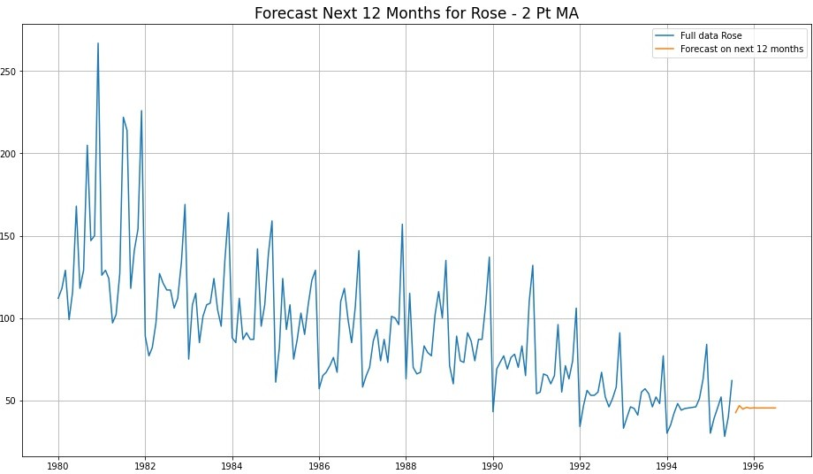

* This model doesn’t seem to be predicting very well
* Hence, forecasting on the second best model - Triple Exponential Smoothing ETS(A, A, A) - Additive Seasonality

|  |  |
| --- | --- |
|  | **Forecast** |
| **1995-08-01** | 42.50 |
| **1995-09-01** | 46.75 |
| **1995-10-01** | 44.63 |
| **1995-11-01** | 45.69 |
| **1995-12-01** | 45.16 |
| **1996-01-01** | 45.42 |
| **1996-02-01** | 45.29 |
| **1996-03-01** | 45.36 |
| **1996-04-01** | 45.32 |
| **1996-05-01** | 45.34 |
| **1996-06-01** | 45.33 |
| **1996-07-01** | 45.33 |

Rose Forecast Values - Next 12 Months - 2 Pt Moving Average

#### Rose Forecast Next 12 months - Triple Exponential Smoothing ETS (A, A, A)

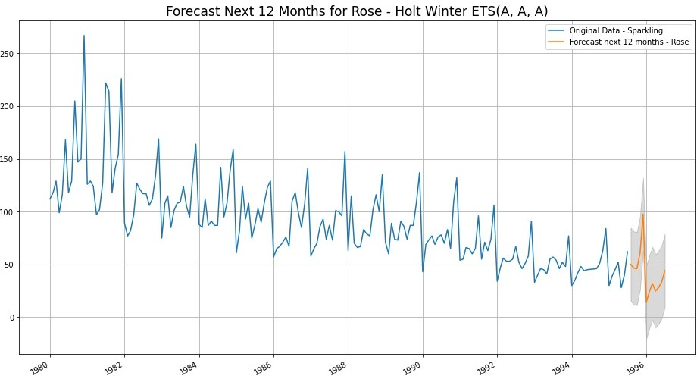

|  |  |
| --- | --- |
|  | **Forecast** |
| **1995-08-01** | 50.02 |
| **1995-09-01** | 46.50 |
| **1995-10-01** | 45.94 |
| **1995-11-01** | 60.72 |
| **1995-12-01** | 97.66 |
| **1996-01-01** | 13.89 |
| **1996-02-01** | 24.29 |
| **1996-03-01** | 31.91 |
| **1996-04-01** | 24.73 |
| **1996-05-01** | 28.12 |
| **1996-06-01** | 33.56 |
| **1996-07-01** | 44.09 |

Rose Forecast Values - Next 12 Months - TES - ETS(A, A, A)

#### Sparkling Forecast Next 12 months - Triple Exponential Smoothing ETS (A, Ad, M) - Damped Trend, Multiplicative Seasonality

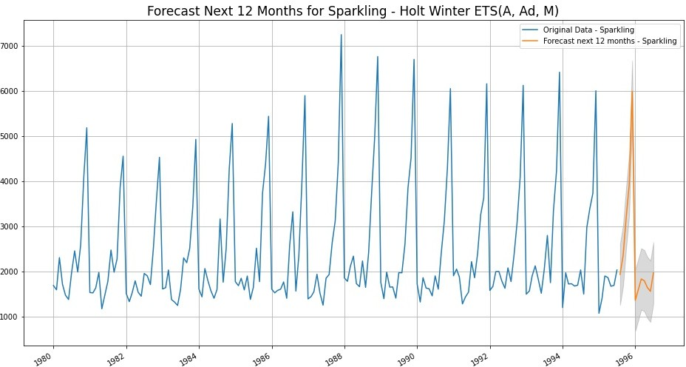

|  |  |
| --- | --- |
|  | **Forecast** |
| **1995-08-01** | 1931.44 |
| **1995-09-01** | 2351.98 |
| **1995-10-01** | 3179.46 |
| **1995-11-01** | 3918.07 |
| **1995-12-01** | 5985.90 |
| **1996-01-01** | 1357.57 |
| **1996-02-01** | 1599.15 |
| **1996-03-01** | 1830.31 |
| **1996-04-01** | 1791.02 |
| **1996-05-01** | 1641.84 |
| **1996-06-01** | 1556.37 |
| **1996-07-01** | 1966.00 |

Sparkling Forecast Values - Next 12 Months - TES - ETS(A, Ad, M)

## 10) Comment on the model thus built and report your findings and suggest the measures that the company should be taking for future sales.

### Rose Wine Sales - Comments :

* Rose wine shows a clear trend of declining sales since 1980
  + This shows decline in popularity of this variant of wine
* Also, there is a clear spike in sales seen in the last quarter of every year from Oct to Dec
  + This might be due to the Holiday season in this period
  + Highest peak in sales is seen in Dec every year
* There is also an instant crashing slump in sales in the first quarter of every year from Jan
  + This might be due to the after effect or hangover of Holidays
* Sales slowly pick up only after May-June



### Rose Wine Sales - Forecast Models :

* Top 2 best models as per lowest Test RMSE were found to be - 2 Pt Moving Average and Holt-Winters - Additive Seasonality & Trend
* 2 Pt Moving Average model, when used for forecasting do not seem to give good predictions. Forecast values level out after a few iterations
* Holt-Winters seems to give a consistent forecast with respect to the data
* Hence, for final forecast of Rose Wine Sales - we choose Holt-Winters

### Rose Wine Sales - Suggestions :

* Firstly, Holiday season is around the corner and forecast shows increasing sales and sharp peak in Dec. Hence, Company should stock up
* But Declining sales of Rose Wine over the long period should be investigated with more data crunching
* Company can rebrand its Rose variant along-with a new Wine-master
* Company should take advantage of the oncoming spike from Aug-Oct by introducing aggressive offers and Ad campaigns.
* This will entice first time Wine drinkers and fence sitters (who don’t have specific loyalties to any particular brand)
* Still if there is no significant upward trend in sales by this Dec, then Company has 2 options - invest in R&D or think of discontinuing this variant and come up with something completely new

### Sparkling Wine Sales - Comments :

* Sparkling wine sales don’t show any upward or downward trend
  + This shows flat sales over long term range
* Also, there is very high spike in sales seen in the last quarter of every year from Oct to Dec
  + This might be due to the Holiday season in this period
  + Highest peak in sales is seen in Dec every year
  + Dec sales are almost 3 times of Sep sales



* Similar to Rose Wine, even in Sparkling sales, an instant crashing slump is seen in the first quarter of every year from Jan
  + This might be due to the after effect or hangover of Holidays
* Sales slowly pick up only from Jul-Aug

### Sparkling Wine Sales - Forecast Models :

* Triple Exponential Smoothing - Holt-Winters Models perform the best on Sparkling datasets, considering the least RMSE on Test data
* There has been incremental improvements in Test RMSE with each tuning of parameters
* Finally, for forecast of Sparkling Wine Sales - we choose Holt-Winters with Multiplicative Seasonality and Additive Damped Trend

### Sparkling Wine Sales - Suggestions :

* Even for Sparkling, Holiday season is around the corner and forecast shows increasing sales and sharp peak in Dec. Hence, Company should stock up
* Sparkling wine has great holiday sales, so this shows popularity.
* So no need to introduce any offers here but hammering Ads are suggested in these times of Oct-Dec. This will drive sales even further.
* Sparkling wines are generally associated with celebrations and mainly to burst open.
* A special designer bottle can be introduced at a cheaper price just for bursting. This will maximise profits
* Year on Year sales do not show any significant increase or decrease
* Though, Holiday spikes are extreme, but general Year on Year sales need to be investigated more. Early period from Jan should be used to do this deep dive

—————— END OF PROJECT ——————